CHAPTER 12 | Firms in Perfectly

Competitive Markets

Solutions to End-of-Chapter Exercises

|  |  |
| --- | --- |
| **12.1** | Perfectly Competitive Markets  Learning Objective: Explain what a perfectly competitive market is and why a perfect competitor faces a horizontal demand curve. |
|  |
|  |

Review Questions

**1.1** Perfectly competitive markets share three characteristics: (1) there are many buyers and sellers, (2) all firms are selling identical products, and (3) there are no barriers to firms entering the market.

**1.2** A price taker is a buyer or seller that is unable to affect the market price. Firms in competitive markets are price takers. Because a firm in a perfectly competitive market is very small relative to the market, and because it is selling exactly the same product as every other firm, it can sell as much as it wants to without having to lower its price. If the firm raises its price, the firm will sell nothing.

**1.3** The graph will look like Figure 12.2 on page 395. The graph on the left shows the market supply and demand curves for corn. The graph on the right shows the demand for corn produced by one corn farmer.

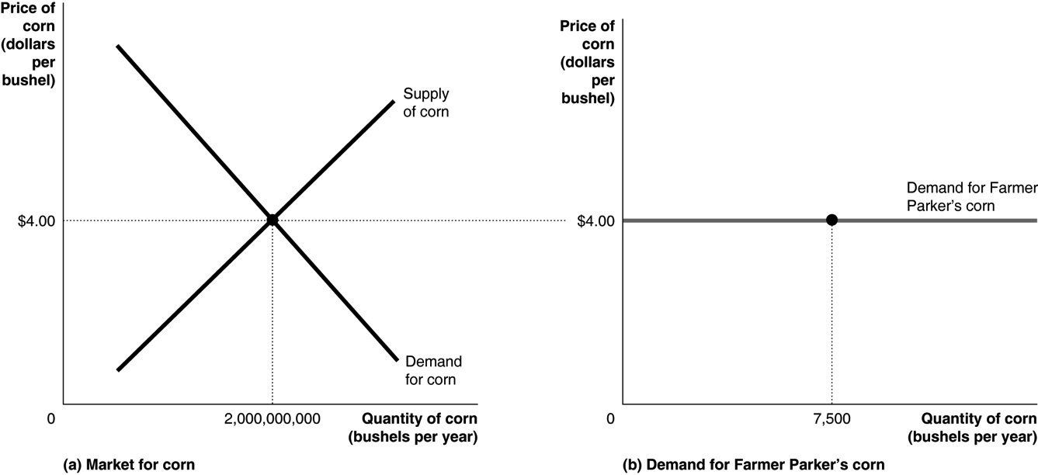

Problems and Applications

**1.4** (a) is perfectly competitive; (b) is not perfectly competitive because the goods being sold are not identical; (c) is not perfectly competitive because there are not enough sellers, the products being sold are not identical, and there are barriers to new firms entering the market; and (d) is not perfectly competitive primarily because the products are not identical.

**1.5** Most consumers are too small relative to the market to affect the price. Most firms, on the other hand, are large enough relative to their markets that they are able to affect the price.

**1.6** The remark confuses the market demand for wheat with the demand facing one farmer selling wheat. Remember that the units used in drawing the market demand curve are much larger than the units used in drawing the individual farmer’s demand curve.

**1.7** The company is a price taker because it is in a “very competitive industry.” The company should charge the market price.

|  |  |
| --- | --- |
| **12.2** | How a Firm Maximizes Profit in a Perfectly Competitive Market  Learning Objective: Explain how a firm maximizes profits in a perfectly competitive market. |

Review Questions

**2.1** A firm in a perfectly competitive market is a price taker and can sell as many units as it wishes at the market price *P*. By selling an additional unit, the firm receives additional (or marginal) revenue of *P*. Because each unit is sold at *P,* the average revenue will also equal *P,* and we get the result *P = MR = AR*.

**2.2** As long as *MR* > *MC*, a firm should continue to expand production because doing so adds more to its total revenue than to its total cost, thereby increasing total profit. When a firm reaches the level of output at which marginal revenue equals marginal cost, it has reached the point where producing that unit of output will add as much to its total revenue as it does to its total cost, which means that total profit cannot be increased further and therefore must be at a maximum.

**2.3** In a perfectly competitive market, *MR = P*, making these two conditions equivalent.

Problems and Applications

**2.4** Disagree. A firm maximizes profit by selling where marginal revenue is equal to marginal cost. If a firm stops producing a quantity for which marginal revenue is greater than marginal cost, then it could increase its profits by producing more. Firms are not interested in maximizing their profit per unit sold; they are interested in maximizing their total profits.

**2.5** Revenue is the total dollar amount of a firm’s sales. Firms are interested in what they have left over from their revenues after they have paid all of the costs of producing the goods they sell. Profit is what’s left over when you subtract total cost from total revenue. That is why firms maximize profit rather than revenue. A revenue-maximizing firm is likely to produce more output than if it were maximizing profit because for the typical firm, revenue is increasing past the quantity where profit starts to decline.

**2.6** Farmer Parker will produce where *MR = P = MC*, which in this case is 6 bushels. Profit = total revenue − total cost = ($5.50 × 6) − $29.00 = $4.00.

**2.7** Assuming a market price of $7 a bushel, Farmer Parker will still produce 7 bushels because marginal revenue is now exactly equal to the marginal cost of $7.00. Profit (*TR – TC*, or   
$49.00 − $35.50) is still $13.50.

**2.8** Farmer Parker’s fixed costs are $10. The increase in fixed costs to $20 will not affect marginal cost, so profit is still maximized at seven bushels of wheat because that is where marginal revenue equals marginal cost. Farmer Parker’s profit, however, would now be $3.50 instead of $13.50.

|  |  |
| --- | --- |
| **12.3** | Illustrating Profit or Loss on the Cost Curve Graph  Learning Objective: Use graphs to show a firm’s profit or loss. |

Review Questions

**3.1** The graph should look like the graph in Step 4 of Solved Problem 12.3 (which is reproduced here).

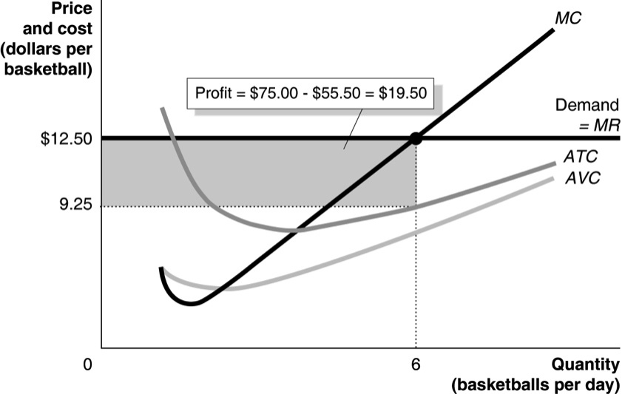

**3.2** The graph should look like the graph in Step 6 of Solved Problem 12.3 (which is reproduced here).

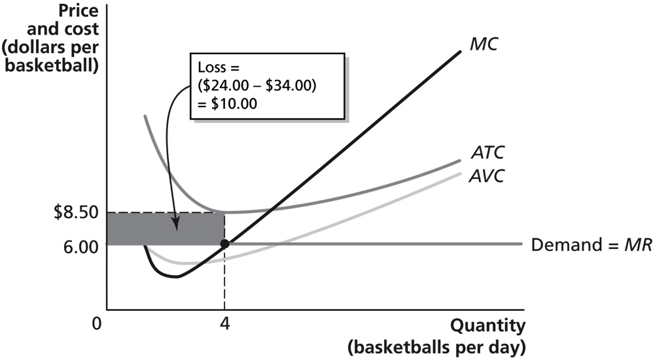

Problems and Applications

**3.3 a.** To maximize profit, Frances will produce the level of output where marginal revenue is equal to marginal cost. Frances will charge the market price of $1.80. Her profit-maximizing output level is 6 earrings. She should expand output up to the point where *MR = MC*, but remember that in a competitive market *MR = P*. The sixth earring’s marginal cost is $1.60 (see the table that follows listing values for marginal cost at each level of output), which is less than the marginal revenue from selling it, but the seventh earring’s marginal cost is $1.90, which is slightly more than the marginal revenue from selling it. Making the sixth earring increases profit, but making the seventh earring would reduce profit. Her profit = total revenue – total cost = (price × quantity) – total cost = ($1.80 × 6) − $6.78 = $4.02.

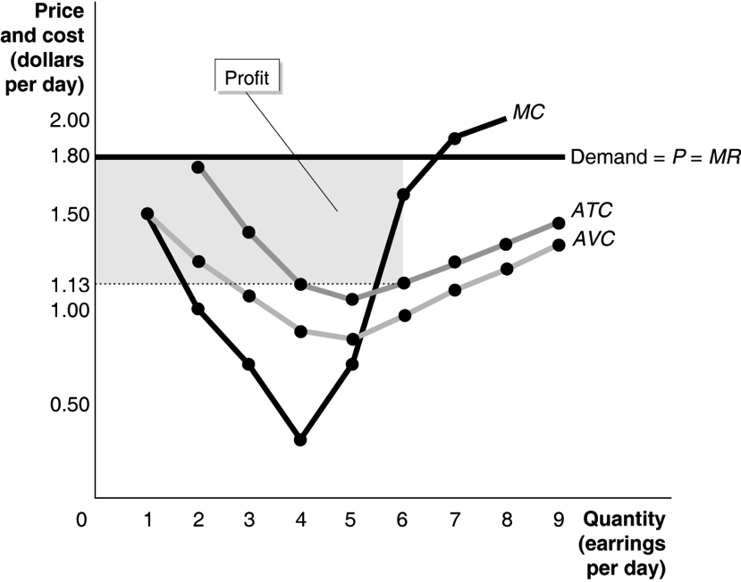

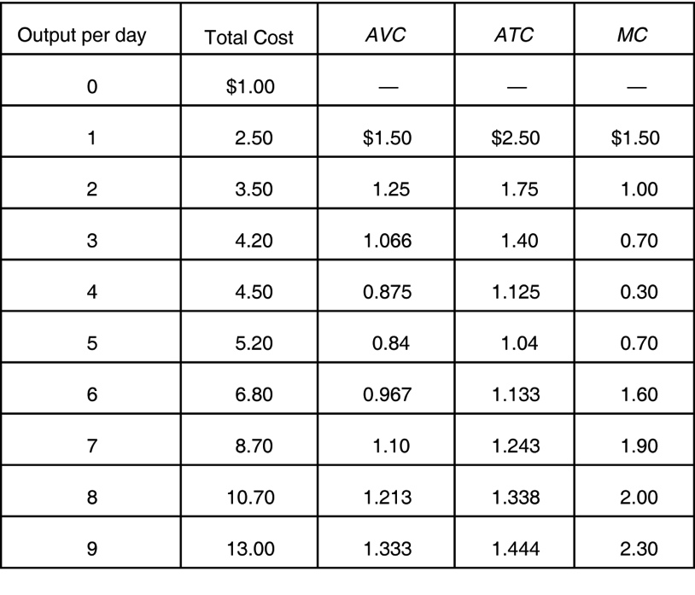

**b.** Frances will charge $1 and produce 5 earrings. Her loss will be (5 × $1) − $5.20 = $0.20, which is smaller than the loss of $1 (which is equal to her fixed cost) if she shuts down.

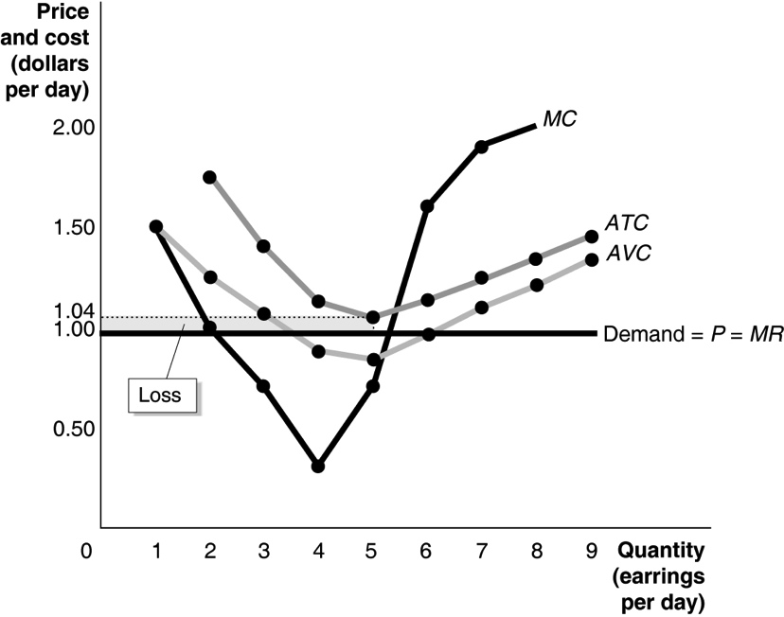

**c.** If the price falls to $0.25, she will shut down, because this price is less than the minimum point on her *AVC* curve. Her loss will be equal to her fixed cost of $1.

**3.4** If the price fell to $2.50 Andy would shut down and not produce any basketballs. The price would be less than average variable cost at all output levels, as is shown in the table on page 400. If Andy shuts down, his loss would equal his fixed cost of $10.00.

**3.5** This argument is incorrect. To maximize profit, the firm should produce up to the point where marginal revenue equals marginal cost. By producing only *Q*1, the firm will miss out on profit to be made on units between *Q*1 and *Q*2.

**3.6** The goal for Texas Instruments, like most firms, is to maximize its profit. Because profit is calculated by taking the difference between total revenue and total cost, a firm can have very high revenue but still have small profit if its costs are high. In this case, Texas Instruments can have a higher profit even when its revenue is falling if its costs are falling even more.

**3.7** If the price of oil doubles, the market demand for solar panels would increase. As the market demand for solar panels increases from *D*1 to *D*2 (in the graph on the left), the market price of solar panels rises from *P*1 to *P*2. As the market price rises, the price that each firm charges rises also (from *P*1 to *P*2 in the graph on the right). As shown in the graph on the right, the representative firm was initially suffering a loss. With the higher price, the representative firm could now potentially earn a zero economic profit, depending on the size of the price increase.



**3.8 a.** To maximize profit, Marguerite should produce at the level of output in which *MR* = *MC*. So Marguerite should produce 100 caps.

**b.** Marguerite will earn a profit (*TR* – *TC*) of $200 because at 100 caps, *TR* = $1,100 and *TC* = $900.

**c.** If Marguerite decides to shut down, she will incur a loss equal to her total fixed cost. Total fixed cost = (*ATC* – *AVC*) × *Q*. So total fixed cost, or the amount of Marguerite’s loss, is: ($9 –$6) × 100 = $300.

|  |  |
| --- | --- |
| **12.4** | Deciding Whether to Produce or to Shut Down in the Short Run  Learning Objective: Explain why firms may shut down temporarily. |

Review Questions

**4.1** In the short run, a firm will shut down if the price falls below the minimum point on its average variable cost curve. In the long run, a firm will shut down (and exit the industry) if the price is below the minimum point on its average total cost curve. In the short run, the firm is willing to accept losses because it cannot do anything about its fixed costs—and must pay them whether or not it is producing anything. In the long run, however, the firm will close down and exit the industry if it expects continued losses.

**4.2** The perfectly competitive firm’s supply curve can be directly derived from its marginal cost curve. The firm will produce where *P* = *MC* if price is at or above the shutdown point at the minimum of *AVC*.

**4.3** The market supply curve is derived by adding up the quantity supplied (using the marginal cost curves) by each firm in the market at each price.

Problems and Applications

4.4 **a.**

|  |  |  |  |  |  |
| --- | --- | --- | --- | --- | --- |
| **Output per Week** | **Total Cost** | ***AFC*** | ***AVC*** | ***ATC*** | ***MC*** |
| 0 | $100 | — | — | — | — |
| 1 | 150 | $100.00 | $50.00 | $150.00 | $50.00 |
| 2 | 175 | 50.00 | 37.50 | 87.50 | 25.00 |
| 3 | 190 | 33.33 | 30.00 | 63.33 | 15.00 |
| 4 | 210 | 25.00 | 27.50 | 52.50 | 20.00 |
| 5 | 240 | 20.00 | 28.00 | 48.00 | 30.00 |
| 6 | 280 | 16.67 | 30.00 | 46.67 | 40.00 |
| 7 | 330 | 14.29 | 32.86 | 47.15 | 50.00 |
| 8 | 390 | 12.50 | 36.25 | 48.75 | 60.00 |
| 9 | 460 | 11.11 | 40.00 | 51.11 | 70.00 |
| 10 | 540 | 10.00 | 44.00 | 54.00 | 80.00 |

**b.** Edward should produce 7 lamps, and he will make a profit = $350 – $330 = $20.

**c.** No, Edward should only shut down if the price falls below the minimum point on his *AVC* curve, which is $27.50.

**4.5 a.**

|  |  |  |  |  |  |
| --- | --- | --- | --- | --- | --- |
| **Output per Week** | **Total Cost** | ***AFC*** | ***AVC*** | ***ATC*** | ***MC*** |
| 0 | $100.00 | — | — | — | — |
| 1 | 155.70 | $100.00 | $55.70 | $155.70 | $55.70 |
| 2 | 205.60 | 50.00 | 52.80 | 102.80 | 49.90 |
| 3 | 253.90 | 33.33 | 51.30 | 84.63 | 48.30 |
| 4 | 304.80 | 25.00 | 51.20 | 76.20 | 50.90 |
| 5 | 362.50 | 20.00 | 52.50 | 72.50 | 57.70 |
| 6 | 431.20 | 16.67 | 55.20 | 71.87 | 68.70 |
| 7 | 515.10 | 14.28 | 59.30 | 73.58 | 83.90 |
| 8 | 618.40 | 12.50 | 64.80 | 77.30 | 103.30 |
| 9 | 745.30 | 11.11 | 71.70 | 82.81 | 126.90 |
| 10 | 900.00 | 10.00 | 80.00 | 90.00 | 154.70 |

**b.** Using the *MR* = *MC* rule, Rafferty should produce 7 pairs of boots per week at a price of $100 per pair. If he produces 7 pairs of boots, his total revenue will be $700, his total cost will be $515.10, so his profit will be $184.90.

**c.** If price falls to $65, Rafferty should produce 5 pairs of boots per week. By producing 5 pairs of boots per week and charging a price of $65 per pair, Rafferty will earn total revenue of $325. Because his total cost of producing five pairs of boots is $362.50, he will incur a loss of $37.50.

**d.** By producing 3 pairs of boots per week and charging a price of $50 per pair, Rafferty will earn total revenue of $150. Because his total cost of producing 3 pairs of boots is $253.90, he will suffer a loss of $103.90. At this point, Rafferty would minimize his losses by shutting down in the short run because *P* ($50) is less than *AVC* ($52.50); in other words, Rafferty would suffer a loss of $100 by shutting down, as opposed to a loss of $103.90 by producing 3 pairs of boots.

**4.6 a.** Total cost = *A + B + C*

**b.** Total revenue = *A + B*

**c.** Variable cost = *A*

**d.** Loss = *C*

The firm will continue to produce in the short run because its revenue is greater than its variable costs.

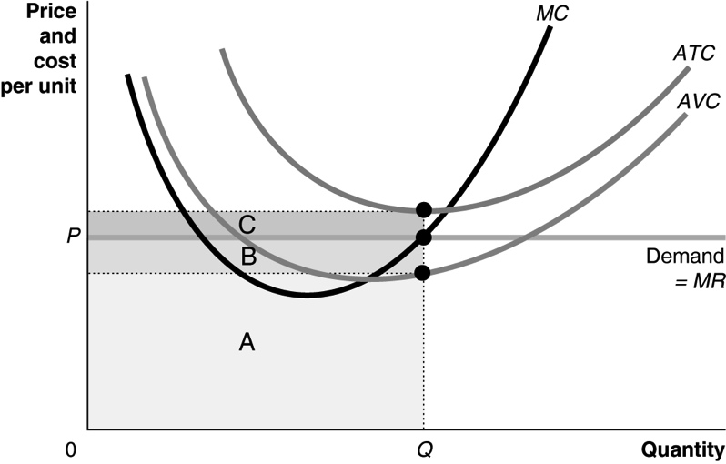

**4.7 a.** The interest payments these firms make are a fixed cost because, regardless of how many solar panels firms produce, the interest payments on their loans will not change.

**b.** The quotation is accurate. A firm cannot do anything about its fixed costs in the short run. In other words, firms have to pay their fixed costs however much output they produce. So if a firm can cover all of its variable costs and pay at least some of its fixed costs, it will suffer a loss, but the loss will be smaller than if the firm shut down completely. In the long run, however, any firm that continues to suffer losses will have to exit the industry.

**4.8** You should continue running the copy store as long as the revenue you earn covers your variable costs. The rent and interest and repayment on the loan are fixed costs that you cannot avoid paying even if you shut down. Therefore, you should ignore those costs in the short run (until the year’s lease expires).

**4.9** Due to the lease it signed, AXA is obligated to pay its rent of $88 per square foot for the duration of its contract. As a result, it is better for AXA to get something ($40 per square foot) for the 300,000 square feet that it is not using than to leave it empty and get nothing. In the long run, however, after the current lease expires, AXA should enter into a new contract that only involves the 1.7 million square feet of office space that it actually needs.

|  |  |
| --- | --- |
| **12.5** | “If Everyone Can Do It, You Can’t Make Money at It”: The Entry and Exit of Firms in the Long Run  Learning Objective: Explain how entry and exit ensure that perfectly competitive firms earn zero economic profit in the long run. |
|  |

Review Questions

**5.1** When firms in an industry are earning economic profits, new firms will enter the industry. When firms in an industry are suffering economic losses, some of those firms will exit the industry.

**5.2** A firm earning zero economic profit would continue to produce, even in the long run, because the firm’s owners are earning as much as they would earn elsewhere—they are covering the opportunity cost of their investment.

**5.3** The long-run supply curve in a perfectly competitive market will be a horizontal line if it is a constant-cost industry—that is, if the typical firm’s average cost curves are unchanged as the industry expands or contracts. If the firm is in an increasing-cost industry, the long-run supply curve will slope upward. If the firm is in a decreasing-cost industry, the long-run supply curve will slope downward. Figure 12.10 (b), which is reproduced below, shows how a perfectly competitive constant cost industry adjusts to a permanent decrease in demand.

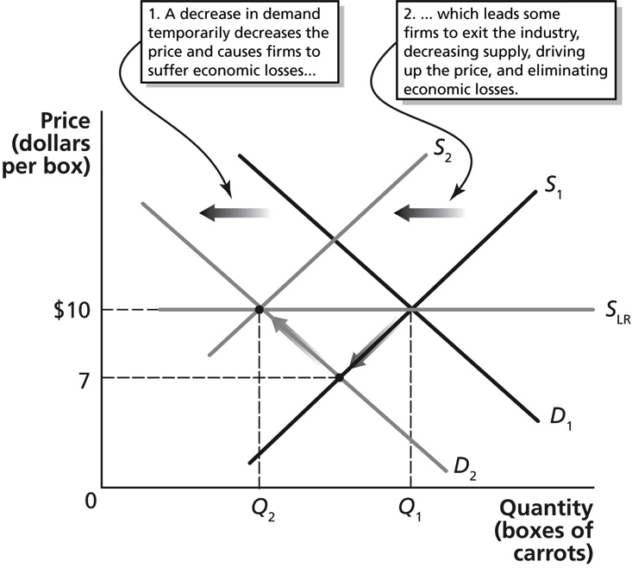

Problems and Applications

**5.4** To find her economic profit, we need to subtract the opportunity cost of her time and the opportunity cost of the funds she is investing in her business from her accounting profit: $80,000 − $75,000 − $3,000 = $2,000.

**5.5** As more firms enter the industry, the market supply curve shifts to the right. This shift leads to a lower market price received by firms already in the industry, causing economic profit to be driven to zero in the long run. As more firms exit the industry, the market supply curve shifts to the left. This shift leads to a higher price received by firms remaining in the industry, resulting in these firms breaking even in the long run.

**5.6** In general, economists would disagree. In a competitive industry, no matter how great demand may be, if there are no barriers to firms entering the industry, profits will be competed away in the long run.

**5.7** Because the carrot market is perfectly competitive, when the market price falls to $7, Sacha must match it or her sales will fall to zero.

**5.8** More firms will exit in a constant cost industry as a result of a decrease in demand because a decrease in demand will result in a lower price, which in turns leads to economic losses. As a result, firms will exit the industry, shifting the supply curve to the left. In an increasing-cost industry, as total output in the industry falls, the average costs of the typical firm decline. As a result, more firms will be able to break even at the lower price, so fewer firms will exit the industry. For a given decline in demand, the industry supply curve will not shift as far to the left in an increasing-cost industry as in a constant-cost industry.

**5.9** Nicholas must consider the opportunity cost of quitting Sun and going to work for himself. In addition to the monetary costs he incurs in developing the games, his opportunity costs will also include what he has given up by leaving Sun, including his salary and all benefits he received from the firm when he was a full-time employee.

**5.10** The remark is incorrect. The student has confused accounting profit and economic profit. Zero economic profit includes a positive accounting profit and a normal rate of return on the investment by the owners of the firm.

**5.11** **a.** Although the old gold mines still had gold, at the previous price of gold, the cost of operating the mines must have been too high for mining companies to earn a profit from these mines. The increase in the international price of gold led gold mining to become more profitable. As a result of increased profits, firms decided they could now profitably operate these old mines.

**b.** As more firms enter the market for gold mining, the market supply of gold will increase, causing the price of gold to decrease. As price falls, economic profits are reduced.

**5.12** In the graph on the left, the increase in the demand for laptop computers causes the demand curve to shift from *D*1 to *D*2, temporarily driving the price up to *P*3. As the production of laptops increases, more orders are placed for laptop displays. As production of laptop displays increases, their cost and price fall because of economies of scale. As shown in the graph on the right, with increased demand and lower average and marginal costs, the firms that assemble laptops can make economic profits at *P*3. The result is that new firms enter the industry, the industry supply curve shifts from *S*1 to *S*2, driving down the price to *P*2 and eliminating economic profits. Because the price of laptop computers declines as output increases, the long-run supply curve is downward sloping. This is a decreasing-cost industry.

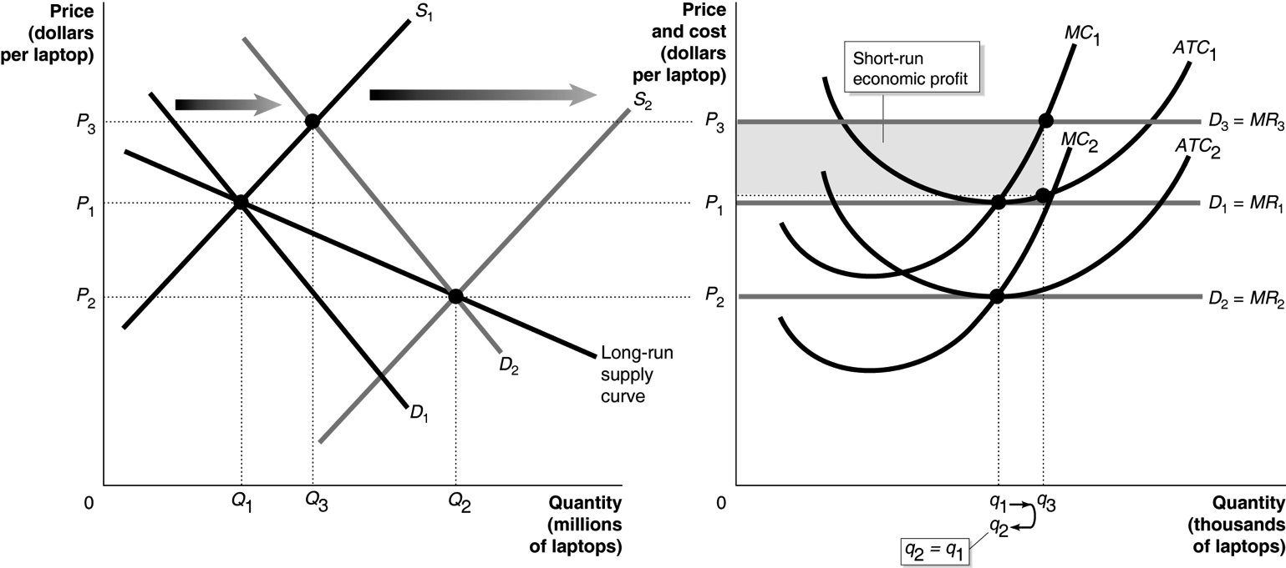

**5.13** Vegetable growers switched from selling to supermarkets to selling in farmers’ markets because they could make economic profits for a few years even though in the long run their profits were no higher.

**5.14**  As soybean farmers that incur losses exit the industry, the market supply of soybeans decreases. This decrease in market supply will in turn result in a higher market price for soybeans. As the market price increases, the losses that soybean farmers suffer will get smaller and, in the long run, ultimately be driven to zero.

|  |  |
| --- | --- |
| **12.6** | Perfect Competition and Efficiency  Learning Objective: Explain how perfect competition leads to economic efficiency. |

Review Questions

**6.1** If consumers want more of a product, the market will supply it. As demand increases, the price of the product increases, and the profits firms earn rise. Higher profits lead existing firms to expand production and new firms to enter the industry. If consumers want less of a product, the market will supply less of it. As demand decreases, the price of the product falls and firms begin to suffer losses. Losses lead existing firms to reduce production and some firms to leave the industry. In this way, consumers are able to dictate to firms the quantities of each good or service the firms produce.

**6.2** Allocative efficiency is the state of the economy in which production reflects consumer preferences; in particular, every good or service is produced up to the point where the last unit provides a marginal benefit to consumers equal to the marginal cost of producing it. Productive efficiency is the situation in which a good or service is produced at the lowest possible average cost. Productive efficiency deals with how a good or service is produced, while allocative efficiency deals with producing the goods and services that consumers value most.

**6.3** Consumers purchase output up to the point where price equals marginal benefit. Under perfect competition, firms produce up to the point where price equals marginal cost. Perfect competition, therefore, generates an equilibrium output where marginal benefit equals marginal cost, which represents allocative efficiency. In a perfectly competitive industry, free entry and exit ensures that, in the long run, firms are producing where average costs are minimized, thereby ensuring that productive efficiency is also achieved.

Problems and Applications

**6.4** The student is correct to note that a firm’s goal is to maximize profit and not consumer welfare. However, consumers will not purchase past the quantity where marginal benefit equals price, and given that firms produce up to the quantity where price equals marginal cost, we get the efficient outcome the text states. Efficiency is achieved despite consumers and producers acting in their own self-interest.

**6.5 a.** Because at the profit-maximizing level of output *P* = *ATC*, Karl is earning zero economic profit.

**b.** Karl’s firm illustrates both productive and allocative efficiency. Productive efficiency occurs when a firm operates at the lowest possible cost, and Karl’s firm is operating at the lowest point on its *ATC* curve. Allocative efficiency occurs when a firm operates where *MR* (or price) is equal to *MC*, and Karl’s firm is producing at that point.

**6.6** In perfectly competitive markets, firms may temporarily earn greater profits from a reduction in costs. However, in the long run, these profits will lead to new firms entering the market. New firms entering the market will shift the supply curve to the right, resulting in lower prices. Lower prices benefit consumers but leave the typical firm just breaking even in the long run.

**6.7** The law would be inadvisable because, in the long run, competition will force the price of pencils to the economically efficient level. When firms earn a profit, new firms will enter the industry in the long run. New firms entering the industry will cause the supply curve to shift to the right, which will lower prices and eliminate economic profits. In the long run, without the need for a law being passed, prices will be equal to the average total cost of production, which means that firms will be breaking even.

**6.8** In the long run, firms typically break even on their investment in producing high technology goods. Competition between the key players in the LCD, LED, and plasma television market pushed prices down. Sony would risk losing all its customers to its competitors if it raised its prices. This analysis implies that Sony and its competitors in the television manufacturing industry are unlikely to earn an economic profit in the long run.

**6.9** Even though demand is strong for visual effects, the higher revenues that accompany the strong demand are apparently not sufficient to enable firms to earn a significant profit. Once again, we can see that intense competition can make it difficult for firms to earn a profit even when demand for their product is high.

**6.10** If the apple diet becomes wildly popular, the demand for apples will increase. An increase in demand will increase the price of apples and increase the demand for land needed to grow apples. As the land outside of New York City again becomes desirable for apple production, the number of apple orchards around New York City will likely increase. An increase in land used for apple growing will decrease the supply of land used for housing developments, which will increase the price of housing in New York City.