CHAPTER 11 | Technology, Production, and Costs

Solutions to End-of-Chapter Exercises

|  |  |
| --- | --- |
| **11.1** | Technology: An Economic Definition  Learning Objective: Define technology and give examples of technological change. |

Review Questions

**1.1** Technology is the process a firm uses to turn inputs into outputs of goods and services. Technological change is a change in the ability of a firm to produce a given level of output with a given quantity of inputs.

**1.2** Technological change could be negative, for instance, when a natural disaster destroys factories, as happened as a result of the earthquake and tsunami that hit Japan in 2011, or when a firm hires less-experienced workers. In these cases, the firm would produce a lower level of output with the same quantity of inputs.

Problems and Applications

**1.3** You should disagree with the statement because firms can experience technological change in the production of existing products, not just in the introduction of new products. Examples include the firm’s managers rearranging the flow of work on a factory floor or the layout of a retail store, thereby increasing production and sales, retraining workers, or installing faster or more reliable machinery or equipment.

**1.4** (b), (c), and (d) are examples of positive technological change because they enable a firm to produce more output with the same quantity of inputs. Choice (a) describes a change in production costs that is the result of a change in the price of an input, not a change in technology. Choice (e) is not an example of technological change because the same quantity of inputs is used to produce the same quantity of output.

**1.5** You should disagree becausethe statement is incorrect. The firms can now produce more output (greater sales) with fewer inputs (fewer trucks). Therefore, this is indeed an example of technological change.

|  |  |
| --- | --- |
| **11.2** | The Short Run and the Long Run in Economics  Learning Objective: Distinguish between the economic short run and the economic long run. |

Review Questions

**2.1** In the short run, at least one of the firm’s inputs is fixed, but in the long run, the firm can vary all of its inputs, adopt new technology, and change the size of its physical plant. The amount of time that it takes to move from the short run to the long run varies from firm to firm.

**2.2** Fixed costs are costs that remain constant as output changes, and variable costs are costs that change as output changes. An example of a fixed cost is the lease payment for a factory or retail store; an example of a variable cost is the cost of raw materials.

**2.3** Explicit costs involve spending money. Implicit costs are nonmonetary opportunity costs, such as the wages the owner of a firm could have earned if he or she worked for someone else.

**2.4** The production function shows the relationship between the inputs employed by a firm and the maximum output it can produce with those inputs. The short-run production function holds constant fixed inputs (such as the number of ovens in Jill’s pizza restaurant in the example in the chapter).

Problems and Applications

**2.5** No, we cannot conclude that Apple is making a profit of $619 per iPhone. The article states that the cost of the materials in Apple’s iPhone5 is $230. Not included in this figure are other costs Apple incurred, including labor costs, those for research and development, advertising, and a return on the investment made by Apple’s owners in the firm. To calculate economic profit, all implicit and explicit costs relating to the production of the iPhone must be subtracted from total revenue.

**2.6** Wage costs are variable if firms increase the number of workers they hire as they increase output. If a publishing company decides to increase the quantity produced of any book it publishes, it does not need to hire any more editors, designers, or other employees (although the firm that actually prints the books may have to). Even if the publishing company decides to publish additional titles, it may not need to hire more editors or other employees because these employees usually work on several titles at the same time. Only if the company intends to significantly increase the number of titles it publishes will it hire more employees. Therefore, publishing companies typically consider their wage costs to be fixed costs, rather than variable costs. For many firms, the cost of utilities can be a mixture of fixed and variable costs. For example, a store may keep its lights on and its outdoor signs lighted day and night. The cost of the electricity to keep these lights on would, therefore, be a fixed cost because the cost does not vary with the quantity of the product sold. On the other hand, if, for example, the store sells photocopies, then the more copies it sells, the more it runs its copy machines, and the more electricity it uses. So that part of its electric bill is a variable cost

**2.7** (a), (d), and (e) are fixed costs because they do not change as the quantity of pizzas produced increases; (b) and (c) are variable costs because they increase as the quantity of pizzas produced increases. The time period under consideration is important. In the long run, all of these costs are variable.

**2.8** The private firms that printed and sold the *Statistical Abstract of the United States* only paid the cost of printing the book, advertising it, and delivering it to customers. They did not pay the fixed (and huge) costs of collecting the data in the first place or the cost of assembling the data from a variety of government reports and other sources. Because the U.S. Census Bureau did have to cover these fixed costs, it sold copies of the *Statistical Abstract* at a higher price.

**2.9**

|  |  |  |  |  |  |
| --- | --- | --- | --- | --- | --- |
| **Quantity**  **of workers** | **Quantity of cars per month** | **Fixed**  **Cost** | **Variable**  **Cost** | **Total**  **Cost** | **Average**  **Total**  **Cost** |
| 0 | 0 | $6,000 | 0 | $6,000 | — |
| 1 | 20 | 6,000 | $4,000 | 10,000 | $500 |
| 2 | 30 | 6,000 | 8,000 | 14,000 | 467 |
| 3 | 40 | 6,000 | 12,000 | 18,000 | 450 |
| 4 | 50 | 6,000 | 16,000 | 22,000 | 440 |
| 5 | 55 | 6,000 | 20,000 | 26,000 | 473 |

**2.10** The opportunity cost is the highest-valued alternative that must be given up to engage in an activity. By keeping the Supersonics in Seattle instead of moving them to Oklahoma City, Bennett would give up $82 million dollars, the difference between losing $63 million by staying in Seattle and gaining $19 million by moving to Oklahoma City. (The team did move to Oklahoma City in 2008.)

**2.11** Jill’s reasoning is faulty. If she could rent out her current building for $4,000 per month, then she would incur an opportunity cost of that amount by using the building herself. Therefore, by moving to the suburbs, Jill’s costs would actually drop by $1,000 per month, which is the difference between the implicit rent of $4,000 she is paying now, which she forgoes by not renting the building, and the cash rent of $3,000 she would pay if she moved.

**2.12** The report included DuPont chemical company’s expected earnings as a loss because the return on the investment represents the opportunity cost of the funds the company had invested. Expected earnings are an implicit cost that must be subtracted from revenue when calculating a firm’s economic profit or loss.

|  |  |
| --- | --- |
| **11.3** | The Marginal Product of Labor and the Average Product of Labor  Learning Objective: Understand the relationship between the marginal product of labor and the average product of labor. |
|  |
|  |

Review Questions

**3.1**

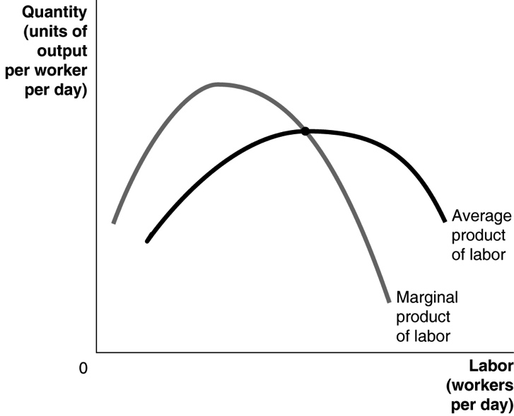

Marginal product normally increases at first due to specialization and division of labor, but it eventually decreases because of the law of diminishing returns. The amount of capital per worker declines as more labor is hired to work with a fixed amount of capital. Therefore, the marginal product of labor falls. When the marginal product of labor is greater than the average product of labor, the average product of labor increases. When the marginal product of labor is less than the average product of labor, the average product of labor decreases. The marginal product of labor is equal to the average product of labor when the average product of labor is at its maximum value.

**3.2** The marginal product of labor initially increases, due to specialization and division of labor, as the number of workers hired increases.

**3.3** The law of diminishing returns is the principle that, at some point, adding more of a variable input (for example, labor) to the same amount of a fixed input (such as capital) will cause the marginal product of the variable input to decline. This principle doesn’t apply in the long run because, in the long run, none of the inputs are fixed; all inputs can vary.

Problems and Applications

**3.4**

|  |  |  |  |
| --- | --- | --- | --- |
| **Quantity of Workers** | **Total Output** | **Marginal Product of Labor** | **Average Product of Labor** |
| 0 | 0 | — | — |
| 1 | 400 | 400 | 400 |
| 2 | 900 | 500 | 450 |
| 3 | 1,500 | 600 | 500 |
| 4 | 1,900 | 400 | 475 |
| 5 | 2,200 | 300 | 440 |
| 6 | 2,400 | 200 | 400 |
| 7 | 2,300 | –100 | 329 |

**3.5**

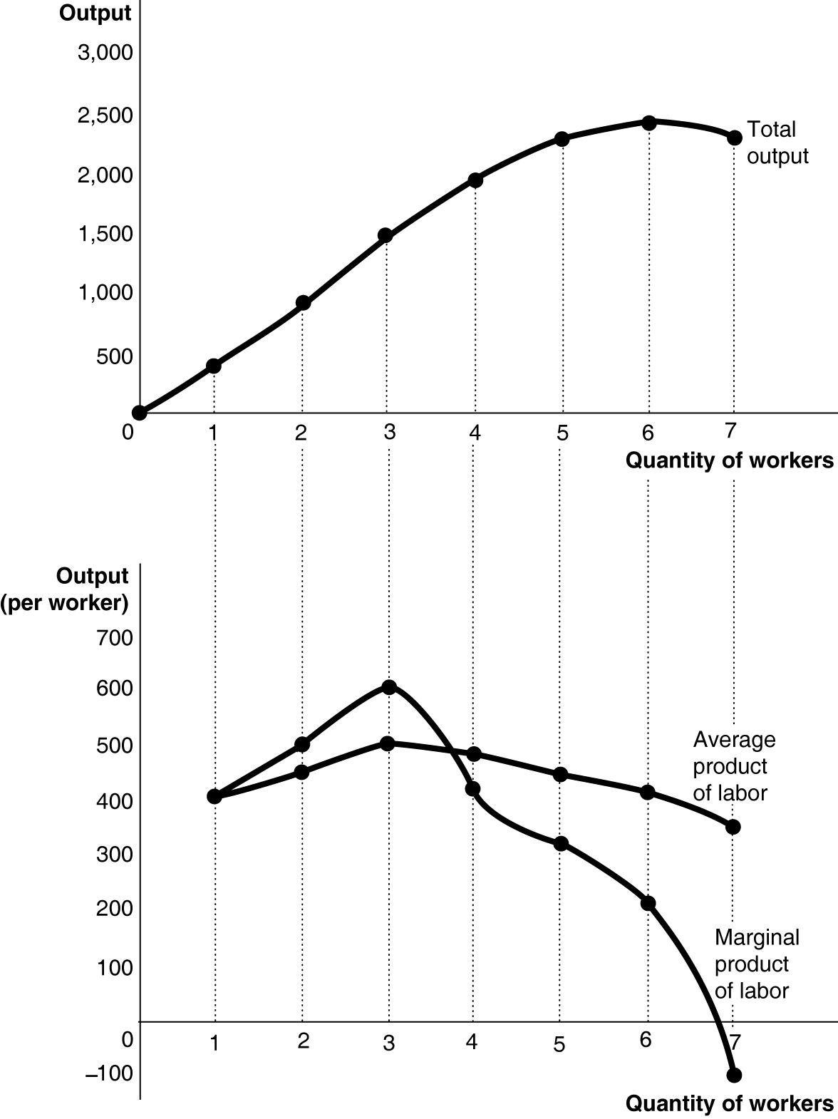

**3.6** The student’s analysis is incorrect. The data in Table 11.3 represent the effects of specialization and division of labor and the law of diminishing returns, rather than the varying quality of the workers.

**3.7** Gains from specialization are not limited to the production of physical goods. In retail stores, for example, there is a division of labor between those who stock the shelves, help customers in the aisles, and operate cash registers.

**3.8** As long as Sally’s GPA for a semester is below her cumulative GPA, her cumulative GPA will fall. The current semester’s GPA is her marginal GPA, while her cumulative GPA is her average GPA. Even if her marginal GPA goes up, her average GPA will go down as long as her marginal GPA is below her average GPA.

**3.9** No, because anything that increases the marginal product of labor must also change the average product of labor.

**3.10** **a.** *AP = Q/L* = 24/4 = 6 pizzas per worker

**b.** *MP* = Δ*Q*/Δ*L* = (28 − 24)/(5 − 4) = 4/1 = 4 pizzas per worker

**c.** If we add the marginal product of the second worker (6 pizzas) to the number of pizzas produced when 1 worker is hired (5 pizzas), then the total number of pizzas produced when 2 workers are hired is 6 pizzas + 5 pizzas = 11 pizzas.

**d.** The law of diminishing returns sets in when the marginal product of labor first starts to fall; so in this case, it sets in with the fourth worker hired (where marginal product falls to 5).

|  |  |
| --- | --- |
| **11.4** | The Relationship between Short-Run Production and Short-Run Cost  Learning Objective: Explain and illustrate the relationship between marginal cost and average total cost. |
|  |
|  |

Review Questions

**4.1** Average total cost is total cost divided by the quantity of output produced; marginal cost is the change in a firm’s total cost from producing one more unit of a good or service.

**4.2** If the marginal product of labor is rising, it means that each additional worker is contributing more additional output than the previous worker. As a result, the additional, or marginal, cost of output must be falling because the additional output takes fewer additional workers to produce. Marginal product and marginal cost are mirror images of each other: When marginal product increases, marginal cost falls, and vice versa.

**4.3** When marginal cost is below average total cost, marginal cost pulls average total cost down, so we are on the downward-sloping section of the U-shaped average total cost curve. When output expands enough, marginal cost rises to equal and then exceed average total cost. When marginal cost is above average total cost, marginal cost pulls average total cost up, so we are on the upward-sloping section of the U-shaped average total cost curve. Therefore, at the point where marginal cost equals average total cost, the average total cost curve stops sloping downward but hasn’t begun sloping upward—that is, the average total cost curve is at its lowest point when the marginal cost curve equals (or intersects) it.

Problems and Applications

**4.4** No, you should disagree. The interest you pay on a loan is a fixed cost, so it would have no effect on the $80 marginal cost of producing another barrel of oil.

**4.5** Yes. As long as marginal cost is below average total cost, average total cost will be decreasing, even if marginal cost is increasing.

**4.6** **a.** No. In this case, average total cost is also always increasing.

**b.** As each unit costs an additional (marginal) cost of $5 to produce, average total cost will also be $5 for each unit. The average cost curve and the marginal cost curve will be a straight line parallel to the quantity axis at $5. Note that this result depends on the assumption stated at the beginning of the problem that the firm has no fixed costs.

**4.7 a.**

|  |  |  |  |  |  |  |
| --- | --- | --- | --- | --- | --- | --- |
| **Quantity**  **of Workers** | **Quantity**  **of Copies**  **per Day** | **Fixed**  **Cost** | **Variable**  **Cost** | **Total**  **Cost** | **Average**  **Total**  **Cost** | **Marginal**  **Cost** |
| 0 | 0 | $40 | $0 | $40 | — | — |
| 1 | 600 | 40 | 40 | 80 | $0.133 | $0.067 |
| 2 | 1,100 | 40 | 80 | 120 | 0.109 | 0.080 |
| 3 | 1,500 | 40 | 120 | 160 | 0.106 | 0.100 |
| 4 | 1,800 | 40 | 160 | 200 | 0.111 | 0.133 |
| 5 | 2,000 | 40 | 200 | 240 | 0.120 | 0.200 |
| 6 | 2,100 | 40 | 240 | 280 | 0.133 | 0.400 |

**b.** The average total cost curve is U shaped; it falls initially and then rises. (Note that in this example, we only get the U shape for the average total cost curve if we compute average total cost to three decimal places. At two decimal places, the average total cost of producing 1,100, 1,500, and 1,800 copies is $0.11; so the average total cost curve will have a flat section.) The marginal cost curve, on the other hand, rises continuously, rather than being U shaped.



**4.8** Average total cost is total cost divided by total output. In this case, average total cost for 10,000 pizzas is $50,000/10,000 = $5.00. Marginal cost is the change in total cost divided by the change in output. In this case, marginal cost from the additional pizza is $11/1 = $11. As the graph shows, when average total cost is rising, marginal cost must be above average total cost. Therefore, Jill is correct to say that her marginal cost must be increasing**.**

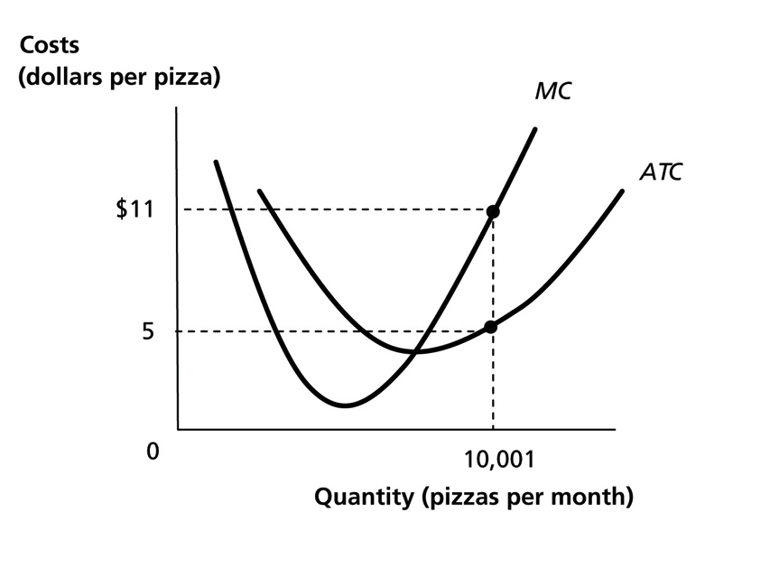

**4.9** Average total cost is total cost divided by total output. In this case, average total cost is $75,002/20,001 = $3.75. Marginal cost is the change in total cost divided by the change in output. In this case, marginal cost is $2/1 = $2. As the graphs show, when average total cost is greater than marginal cost, marginal cost may be either increasing (graph (a) shown below) or decreasing (graph (b) shown below). Therefore, Jill is wrong to say that her marginal cost “must” be increasing because it may or may not be increasing.

**a.** In this case, Jill’s average total cost is above her marginal cost, and her marginal cost is increasing.

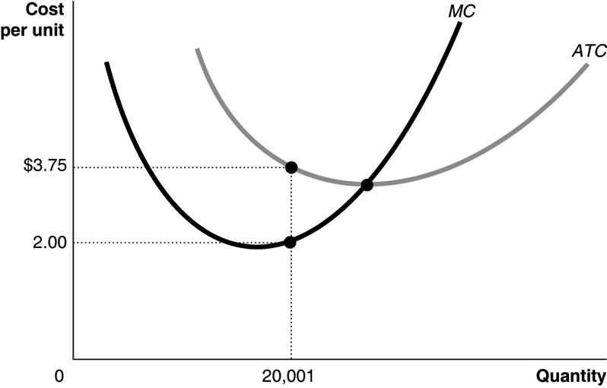

**b.** In this case, Jill’s average total cost is above her marginal cost, and her marginal cost is decreasing.

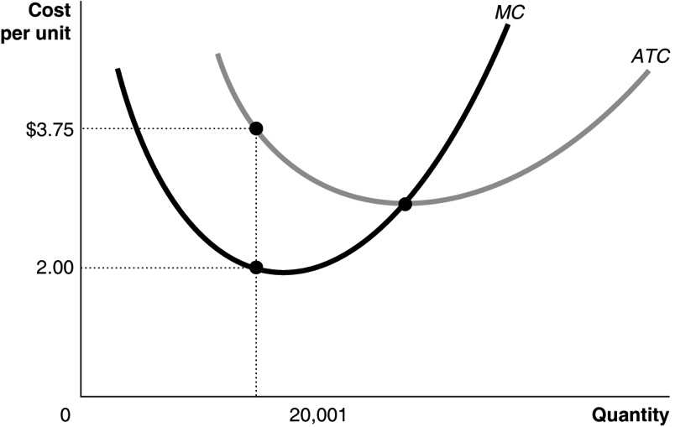

**4.10** **a.** Δ*VC* = *w*Δ*L*

**b.** 

or



**c.** If *w* = $750 and *MPL* is 150, then *MC* = $750/150 = $5.

If the wage falls to $600 and *MPL*is unchanged, then *MC* = $600/150 = $4.

If the wage is $750 and *MP*L rises to 250, then *MC* = $750/250 = $3.

|  |  |
| --- | --- |
| **11.5** | Graphing Cost Curves  Learning Objective: Graph average total cost, average variable cost, average fixed cost, and marginal cost. |
|  |
|  |

Review Questions

**5.1** The marginal cost curve intersects the average variable cost curve and the average total cost curve at their minimum points.

**5.2** The difference between average total cost and average variable cost is average fixed cost. Average fixed cost decreases as output increases, so the difference between average total cost and average variable cost must also continuously decrease. *ATC = AVC + AFC*, so *ATC − AVC = AFC*. As *AFC* continuously decreases, so does *ATC − AVC*.

Problems and Applications

**5.3** **a.** Variable cost = total cost – fixed cost. So, $30,000 − $10,000 = $20,000.

**b.** *AVC = VC/Q* = $20,000/10,000 = $2; *AFC = FC/Q* = $10,000/10,000 = $1.

**c.** The gap must get smaller as output rises because *ATC = AVC + AFC* and *AFC* falls as output rises. So, the dollar difference between *ATC* and *AVC* is greater when the output of tennis balls is 10,000.

**5.4** Fixed costs are like a lump-sum tax because both are fixed amounts that do not change as output changes. Because *AFC = FC/Q*, the “tax” becomes smaller per unit of output as output increases.

**5.5** **a.** For 5 copies, the total cost of 5 scrolls would be equal to the variable costs of 27.83 × 5 = 139.15 because there are no fixed costs. The total cost of 5 codices would be the sum of the variable costs of 20.58 × 5 = 102.9 plus the fixed costs of 58, or 160.9. So the publisher should publish the book as a scroll. For 10 copies, the total cost of 10 scrolls would be equal to the variable costs of 27.83 × 10 = 278.3. The total cost of 10 codices would be the sum of the variable costs of 20.58 × 10 = 205.8 plus the fixed costs of 58, or 263.8. So the publisher should publish the book as a codex.

**b.** As publishers began to publish more copies of each book, the average cost of a book was lower if the book was published as a codex rather than as a scroll.

**5.6** To offer a MOOC, colleges and private companies incur substantial costs to prepare material and design the MOOC so that the material is made available in an attractive and effective way. These are fixed costs, however. Once the MOOC has been designed and made available, the marginal cost of offering the course to one more student is very low. In the graph below, marginal cost is shown as a low, constant amount. In this case, the shape of the average total cost curve is determined largely by the shape of the average fixed cost curve.

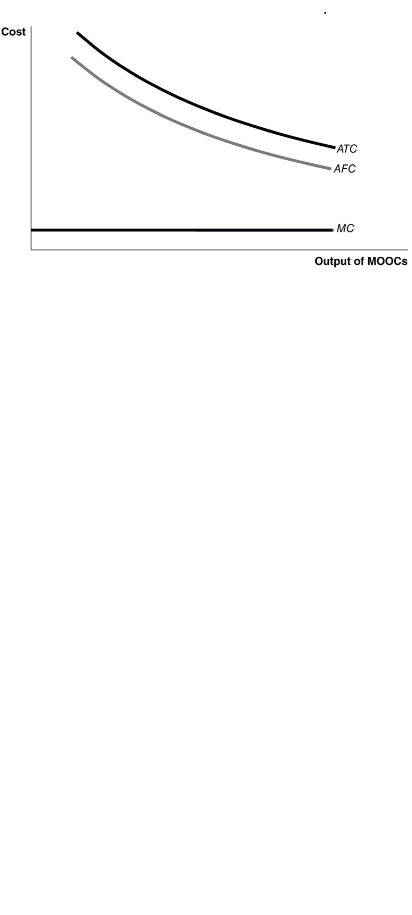

**5.7** **a.** $15

**b.** Total cost = *ATC* × *Q* = $30 × 1,000 = $30,000.

**c.** Variable cost = *AVC* × *Q* = $20 × 1,000 = $20,000.

**d.** Fixed cost = Total cost – Variable cost = $30,000 − $20,000 = $10,000.

**5.8** The *AFC* curve should be downward sloping, not U shaped. Because *AFC* = *TC*/*Q* and because total fixed cost does not change, *AFC* will decrease as quantity increases. *ATC* should be above *AVC*. Because *ATC* = *AFC* + *AVC*, the *ATC* curve will always be above the *AFC* and *AVC* curves.

**5.9** **a.** Marginal cost, average variable cost, and average total cost will all increase; average fixed cost is unaffected.

**b.** Marginal cost, average variable cost, and average total cost will all increase; average fixed cost is unaffected.

**c**. Average fixed cost and average total cost will decrease; marginal cost and average variable cost will be unaffected.

**d.** Average fixed cost and average total cost will increase; marginal cost and average variable cost will be unaffected.

|  |  |
| --- | --- |
| **11.6** | Costs in the Long Run  Learning Objective: Understand how firms use the long-run average cost curve in their planning. |
|  |
|  |

Review Questions

**6.1** In the short run, Total cost = Variable cost + Fixed cost; but in the long run, Total cost = Variable cost because there are no fixed costs in the long run.

**6.2** Minimum efficient scale is the lowest level of output at which all economies of scale have been exhausted. In other words, minimum efficient scale is where the long-run average cost curve stops sloping downward. In the long run, firms that don’t reach minimum efficient scale will have higher average costs than competitors that do reach minimum efficient scale, so they will probably be driven out of business. (However, firms that justify selling at premium prices due to product differentiation can survive. The textbook discusses this last point in Chapter 13.)

**6.3** Economies of scale exist when a firm’s long-run average costs fall as the firm increases output. Firms may experience economies of scale because: (1) a firm’s technology may allow it to increase production with a smaller proportional increase in at least one input; (2) both workers and managers can become more specialized as output expands; (3) large firms may be able to purchase inputs at lower costs than smaller firms can; and (4) as a firm expands, it may be able to borrow money at a lower interest rate, thereby lowering its costs.

**6.4** Diseconomies of scale exist when a firm’s long-run average costs rise as the firm increases output. Diseconomies of scale eventually arise because managing a store or factory above a certain size is simply too complicated.

**6.5** Because short-run average cost includes at least one input that is fixed in quantity, it can never be less than long-run average cost (where there are no fixed inputs or fixed costs).

Problems and Applications

**6.6** Economies of scale occur when a firm’s long-run average costs fall as the firm increases output. By building bigger factories, computer chipmakers will be able to increase the output of computer chips. The more chips these firms are able to produce in each factory, the lower the cost per chip.

**6.7** **a.** Jill’s average total cost will be lower with a smaller restaurant.

**b.** Jill’s average total cost will be lower with a larger restaurant.

**c.** As we can see in Figure 11.6 in the text, economies of scale often take the form of a larger store or restaurant allowing for lower average cost for a large quantity, but actually *higher* average total cost for a small quantity. The larger restaurant may use larger ovens, more tables, or other capital that isn’t efficiently used if Jill is only able to sell a smaller quantity of pizzas.

**6.8 a.** Car rental companies that purchase a large number of cars may be able to purchase them (for use as rentals) at lower costs. In addition, larger car rental companies may also be able to insure these cars and acquire financing for these cars at lower rates. A small car rental firm like Zipcar, with a much smaller number of cars, will likely pay more for buying, insuring, and financing cars. Finally, there may be important fixed costs in running a rental car business that can be spread over a larger quantity of cars being rented.

**b.** The “efficiencies” that might be gained include the economies of scale discussed in part (a). In addition, by consolidating some of the two firms’ marketing, sales, and other operations, the combined firm might have lower costs than each firm had operating separately.

**c**. Avis may have achieved minimum efficient scale before buying Zipcar given its costs as they then were. If the combined company has lower costs, than it can operate more efficiently than the two companies could operate separately.

**6.9** If the price of Japanese mobile phones is high because they are being produced in low volume, then the Japanese firms were not yet at minimum efficient scale in the mobile phone business. Minimum efficient scale is represented on the graph by quantity *Q*M, with an average total cost of *ATC*M. The current volume of mobile phones being produced by the Japanese manufacturers is represented by *Q*A, with an average total cost of *ATC*A.

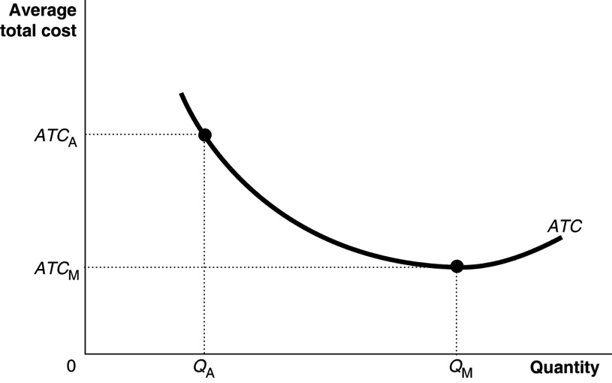

**6.10** CNN and ABC News were on *ATC*1. If the companies had merged, they would move to *ATC*2 and be on the section of the long-run average cost curve that exhibits diseconomies of scale.

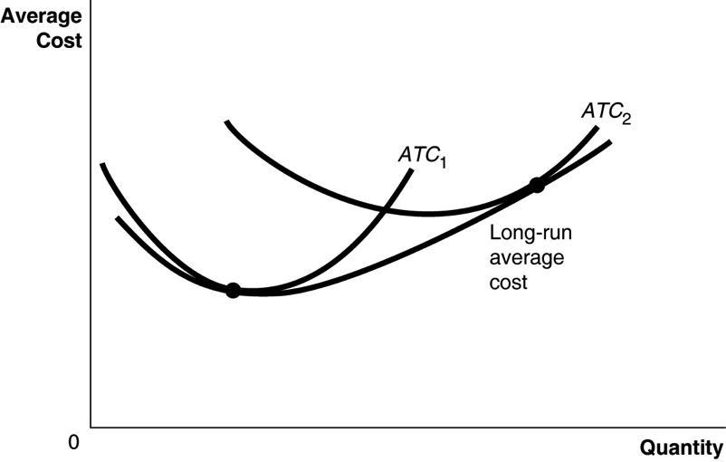

**6.11** Ford would have ended up as the only automobile producer. Other producers would have had higher average costs and, therefore, would not have been able to match his price cuts.

**6.12** If the economies of scale for drilling for oil are greater using fracking methods than when using conventional methods, more companies would use fracking methods. With greater economies of scale, there will likely end up being fewer firms drilling for oil in the United States.

**6.13** The statement is incorrect. The River Rouge plant exhibited diseconomies of scale, a long-run concept, not diminishing returns, which is a short-run concept.

**6.14 a.** Lynch meant that the Nook business would realize economies of scale, so average costs would decrease as more tablets were produced.

**b**. If, with economies of scale, average costs declined while revenues increased, losses would decrease.

**c.** It is possible that the Nook business did realize economies of scale, but revenues fell by more than did costs, resulting in increased losses.

Solutions to Chapter 11 Appendix

Review Questions

**11A.1** An isoquant is a curve that shows all the combinations of two inputs, such as capital and labor, that will produce the same level of output. Its slope is the rate at which a firm can substitute one input for the other while keeping output constant, or the marginal rate of technical substitution (*MRTS*).

**11A.2** The isocost line shows all the combinations of two inputs, such as capital and labor, that have the same total cost. The slope of the isocost line is equal to the ratio of the price of the input on the horizontal axis divided by the price of the input on the vertical axis, multiplied by –1.

**11A.3** The firm wants to minimize the cost of producing any level of output. This occurs where the isoquant and isocost lines are tangent or the *MRTS* equals the ratio of the input prices.

Problems and Applications

**11A.4**

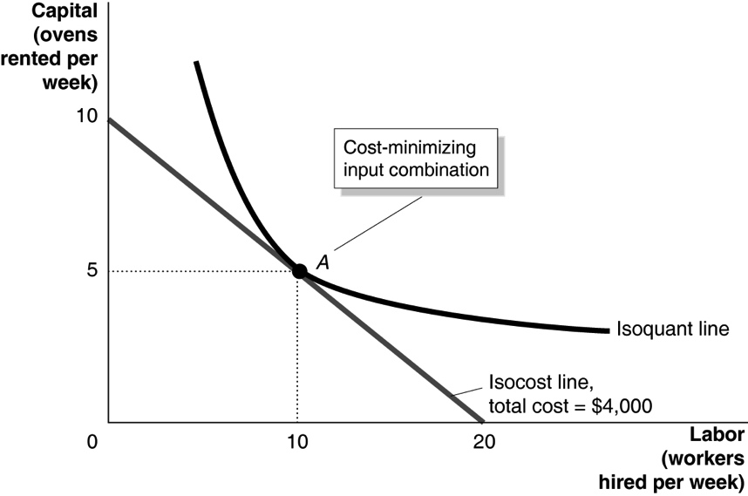

**11A.5** **a.** If total cost is $2,000 and the wage rate and rental price of machines both equal $100, the isocost line’s endpoints are at 20 and 20. Along this isocost curve, the cost-minimizing point for producing 5,000 units is at point *A*.

**b.** If the wage rate is one-fourth the rental price of machines, then we must be on the isocost line whose endpoints are where capital = 10 and labor = 40 because we can buy four times as much labor with a total cost of $1,000. Along this isocost curve, the cost-minimizing point for producing 5,000 units is at point *B*.

**c.** In this case, the isocost line’s endpoints are at 40 and 40, so the cost-minimizing point for producing 12,000 units is at point *C*.

**11A.6**

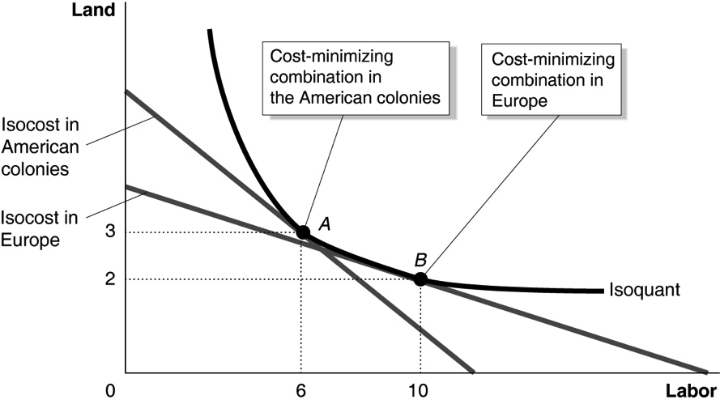

In the colonies, with land cheap and labor expensive, the cost-minimizing input combination was point *A*. In Europe, where land was expensive and labor was cheap, the cost-minimizing input combination was point *B*, with more labor and less land.

**11A.7** To minimize costs Jill should be at a point where 

Plugging in the numbers into our equation, we get:

pizzas per dollar and  pizzas per dollar.

Unfortunately, the ratios are not equal, so Jill isn’t minimizing costs. Jill produces more pizzas per dollar from the last worker than from the last oven. This indicates that she has too many ovens and too few workers. If she hired more workers and rented fewer machines, her *MPL* would fall, and her *MPK* would rise until 

**11A.8** At point *A* the slope of the isocost = −*w/r* = −1/2 ovens per worker, while the slope of the isoquant = *MRTS* = −1 oven per worker (*w* = wage rate; *r* is unit capital rate). Because the slope of the isoquant is greater than the slope of the isocost in absolute value, Jill should employ more workers and fewer ovens (represented by point *B*) to minimize cost for Q = 20,000 pizzas per week.

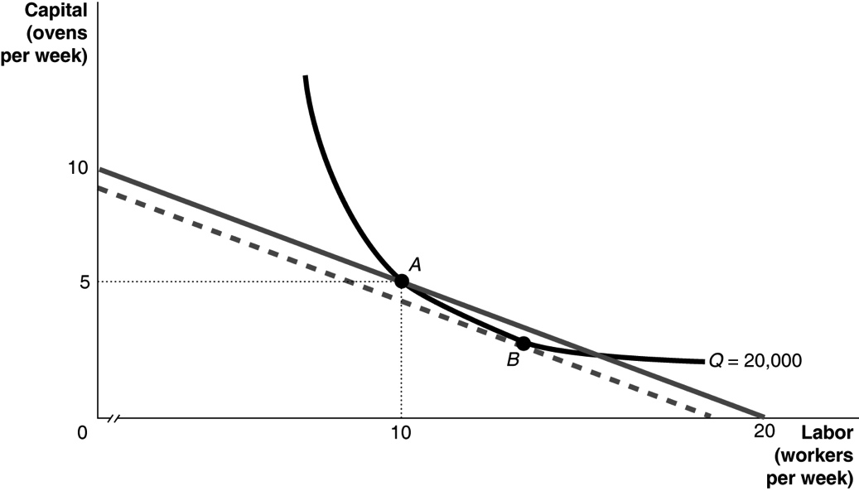

**11A.9**

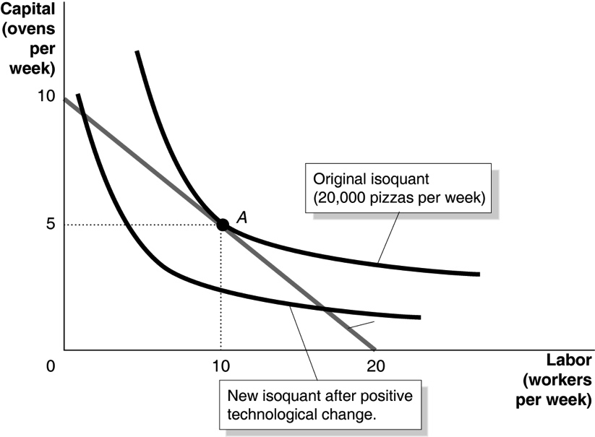

After the positive technological change, Jill can produce 20,000 pizzas per week at a cost of less than $20,000 per week.

**11A.10 a.** Combinations *A* and *B* yield the same output because they are on the same isoquant curve.

**b.** The ratio of the wage rate to the rental price of capital will determine which point along this isoquant Jill chooses.

**c.** The marginal rate of technical substitution is the slope of the isoquant, which is greater (in absolute value) at point *A*.

**11A.11**

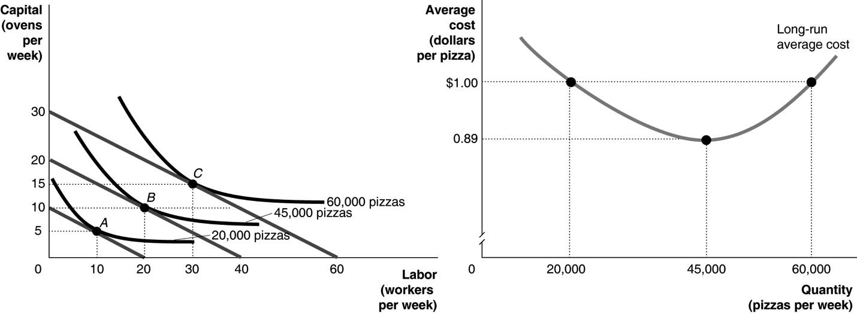

Jill Johnson’s pizza restaurant exhibits economies of scale between 20,000 and 45,000 pizzas per week and diseconomies of scale between 45,000 and 60,000 pizzas per week.

**11A.12** The isoquant curve shows that there are innumerable combinations of workers and machines that can pick the same quantity of oranges per day. In the United States, firms select a point like *A*—using a lot of capital and very little labor—because the isocost curves they face are very steep, due to the fact that in the United States labor is relatively expensive in comparison to capital. In Brazil, firms select a point like *B*—using lots of labor and very little capital—because the isocost curves they face are very flat, due to the relatively low price of labor in comparison to the price of capital in Brazil.

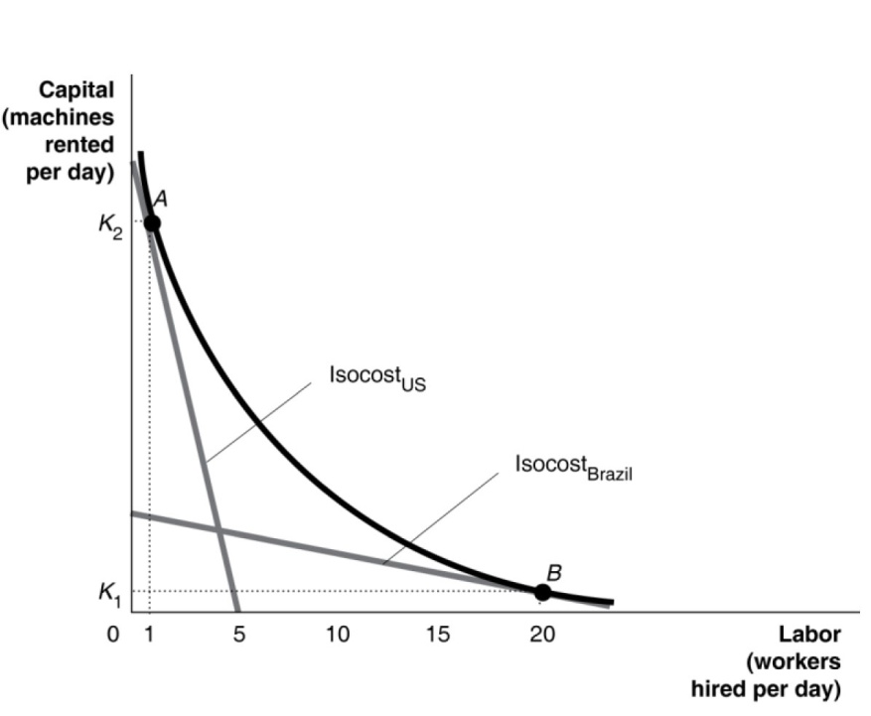

**11A.13** Jill Johnson is producing where the *MRTS* equals the ratio of input prices. Because the ratio of input prices is $600/$2,000, the ratio of the marginal product of labor to the marginal product of capital must be the same. So, $600/$2,000 = *MPL*/12,000, or *MPL* = 3,600 pizzas.

**11A.14** If Massey and Thaler are correct, the team that has the first pick in the draft should trade it to another team for a lower draft pick. The players chosen with the first few picks of the first round of the draft tend to be paid salaries that are much higher relative to their marginal products than is true for players taken later in the first round. A typical team with a high draft pick would increase its ability to win football games at the constant cost represented by the salary cap if it traded for lower draft picks. The 2011 agreement that limits the salaries that drafted players can receive will mean lower overall salaries, so a team with the first pick should still trade it to another team for a lower pick.

**11A.15** **a.** The new isocost line is shown in the graph below. The line has shifted in to reflect the fact that at the same level of total cost, the firm can now hire a maximum of 40 machines or 40 workers.

**b.** New combination is labeled *B* on the graph.

**c.** Compared to point *A*, we can be sure that point *B* uses fewer workers and fewer machines. After both the wage rate and the rental price of machinery doubled, the isocost line shifted in with new intercepts of 40 machines and 40 workers. Because the original combination of capital and labor that minimized the firm’s cost was 40 machines and 40 workers (point *A*), the new combination (point *B*) would have to use fewer workers and fewer machines.

