CHAPTER 3 | Where Prices Come From:
The Interaction of Demand
and Supply
Solutions to End-of-Chapter Exercises
Answers to Thinking Critically Questions

- When Amazon enters the market, supply increases, shifting the supply curve to the right from S₁ to S₂, which decreases the equilibrium price from P₁ to P₂ and increases the equilibrium quantity from Q₁ to Q₂.

- The federal government program that offers to reimburse low-income people for half the price of a new smartphone increases demand, shifting the demand curve to the right from D₁ to D₂. As is shown in the answer above, Amazon entering the market increases supply, shifting the supply curve to the right from S₁ to S_{2.} The equilibrium quantity will definitely increase because quantity increases with an increase in demand and also with an increase in supply. The equilibrium price may increase, decrease, or remain unchanged, depending on the magnitude of the demand and supply changes. In the graph below, equilibrium quantity increases from Q₁ to Q₂, and equilibrium price remains unchanged at P₁, indicating that the increases in demand and supply were of equal magnitude.

3.1 | The Demand Side of the Market  Learning Objective: Discuss the variables that influence demand.
Review Questions
1.1 A demand schedule is a table showing the relationship between the price of a product and the quantity of the product demanded. A demand curve is a curve that shows the relationship between the price of a product and the quantity of the product demanded.
1.2 Ceteris paribus means “everything else equal”—that is, holding everything else constant when examining the relationship between two variables.
1.3 A “change in demand” refers to a shift of the demand curve, while a “change in quantity demanded” refers to a movement along the demand curve as a result of a change in the product’s price.
1.4 The law of demand states that, holding everything else constant, when the price of a product falls, the quantity demanded of the product will increase (and when the price of a product rises, the quantity demanded of the product will decrease). An increase in the price of a product raises the relative price of the product versus other products, causing consumers to substitute away from the higher priced product. The increase in the price of the product also causes a decrease in the real incomes of consumers, and assuming that the product is a normal good, leads consumers to buy less of the product.
1.5 The main variables that will cause a demand curve to shift include: (1) changes in the prices of a related good—substitutes or complements; (2) changes in income; (3) changes in tastes; (4) changes in population or demographics; and (5) changes in expected future prices. An example of substitute goods is Coke and Pepsi, and an example of complementary goods is hot dogs and hot dog buns. An example of a normal good may be a name brand product, like Coca-Cola. An example of an inferior good may be a store branded product, like Sam’s Choice Cola. An example of changes in tastes would be organic produce becoming more popular. An example of changes in population or demographics would be as the number of people over the age of 65 increases, demand for health care services will increase. An example of changes in expected future prices would be if the prices of hybrid vehicles are expected to decline in the future, then today’s demand will decrease.
Problems and Applications
1.6 a. Substitutes
b. Complements
c. Unrelated
d. Substitutes
1.7 Applications, or “apps,” for smartphones are complements to smartphones. The increase in the availability of apps for Android-based smartphones has decreased the demand for Apple iPhones because consumers now find Android-based smartphones to be more useful than they had previously been relative to iPhones.
1.8 a. Smart televisions would be a substitute good to some degree for smartphones. Though smart televisions lack portability, they allow users to connect directly to the Internet.
b. A decline in the price of smart televisions would shift the demand for smartphones to the left, as shown by the shift in demand from D₁ to D₂ in the graph below.
1.9
a. Because the price of a substitute good has declined, the demand curve for Big Macs will shift to the left from D₁ to D₂.
b. The coupon results in a cut in the price of Big Macs, so there will be a movement down the demand curve for Big Macs.
c. Because Big Macs and fries are complements, the demand curve for Big Macs will shift to the left from D₂ to D₁.
d. The information on nutrition may well cause at least some consumers to decide to eat healthier food, so the demand curve for Big Macs will shift to the left from D₁ to D₂.
e. The demand curve for Big Mac’s will shift. If the Big Mac is an inferior good, the demand curve will shift to the left from D₁ to D₂. If the Big Mac is a normal good, the demand curve will shift to the right.
1.10 The demand for UGG boots decreased from 2014 to 2015, which could be caused by a decrease in the price of leather boots, which are a substitute good (UGG boots are sheepskin boots), by a decrease in national income, assuming UGG boots are normal goods, by a decrease in the taste (preference) for UGG boots as a result of a campaign by animal rights activists against using sheepskin to make boots, or by any other factors that decrease demand.
1.11 A movement along the demand curve from point A to point B would be caused by a decrease in the price of traditional wings at Buffalo Wild Wings. A shift to the right of the demand curve from point A to point C could be caused by an increase in the price of pizza or steak (substitutes for wings), an increase in national income assuming wings at Buffalo Wild Wings are normal goods, an increase in the taste (preference) for wings at Buffalo Wild Wings as a result of a successful advertising campaign, or by other factors that increase demand.
1.12 Smartphones are a closer substitute for tablet computers than for e-readers because smartphones and tablet computers have more features in common, such as sending and receiving e-mail, checking your Facebook page, or watching a video.
1.13 China’s one-child policy has increased the relative demand for goods and services consumed by the population over age 14 and has increased the relative demand for goods and services consumed by boys relative to girls. So the demand for children’s toys and children’s books will have decreased. The demand for male clothing will have increased relative to the demand for female clothing.
1.14 The data do not indicate that the demand curve for Priuses is upward sloping. It is likely that factors such as income, fuel prices, and the prices of other hybrid vehicles have changed during these three years. Therefore, the data are likely to represent points from three different demand curves.
1.15 No. The perception of higher quality shifted the demand for the college to the right, and this shift resulted in the increases in the tuition price and in applications.
1.16 As given by the reporter, Posner’s statement confuses a change in demand and a change in quantity demanded. The reduction in the cost of books—the price of books—will increase the quantity demanded of books. It will not cause the demand curve to shift to the right.
1.17 a. Mature markets refer to markets where the product has been available for some time and where there is not much additional room for growth in demand for the product.
b. Sales growth of iPhones would likely be slower in mature markets where the product has been available and many consumers have purchased it than in countries like India where the product is just being widely introduced and few consumers have purchased it.
c. Forecasting sales in mature markets would be easier because there is more historical data to use to measure the response of consumers.

3.2 | The Supply Side of the Market  Learning Objective: Discuss the variables that influence supply.
Review Questions
2.1 A supply schedule is a table that shows the relationship between the price of a product and the quantity of the product supplied. A supply curve is a curve that shows the relationship between the price of a product and the quantity of the product supplied.
2.2. A “change in supply” refers to a shift of the supply curve, while a “change in quantity supplied” refers to a movement along the supply curve as a result of a change in the product’s price.
2.3 The law of supply states that, holding everything else constant, an increase in price causes an increase in the quantity supplied (and a decrease in price causes a decrease in the quantity supplied). The main variables that will cause a supply curve to shift include: (1) changes in the prices of inputs used to make the product, (2) technological change, (3) changes in the prices of substitutes in production (other goods that the producers could be making), (4) changes in expected future prices, and (5) changes in the number of firms. Some examples: If the price of hybrid engines increases, the supply of hybrid cars will decrease. If the technology of producing iPhones improves, the supply of iPhones will increase. If Sony is producing both plasma and LED flat screen televisions, and the price of LED televisions increases, the supply of plasma televisions will decrease. If Toyota believes that the price of the Prius hybrid will increase in the future, it will decrease today’s supply and increase it in the future. As more firms enter the flat-screen television market, the supply of flat-screen televisions will increase.
Problems and Applications
2.4 a. Change in quantity supplied: A movement up the supply curve.
b. Change in supply: The supply curve shifts to the right.
c. Change in supply: The supply curve shifts to the left.
2.5 A movement along the supply curve from point A to point B would be caused by an increase in the price of traditional wings at Buffalo Wild Wings. A shift to the right of the supply curve from point A to point C could be caused by a decrease in the price of feed for chickens, a technological advance in processing chickens, an increase in the number of chicken farms, or other factors that cause an increase in supply.
2.6 The supply of UGG boots decreased from 2014 to 2015. The supply decrease could be caused by an increase in the price of sheepskin (UGG boots are sheepskin boots) or an increase in the price of the machines used to assembly the boots, an increase in the price of other types of boots that UGG could produce, or other factors that cause a decrease in supply.
2.7 Not necessarily. Firms may have different costs of producing smartphones and, therefore, supply different quantities at the same price.
2.8 The increase in the quantity supplied is likely to be larger the longer the time period being considered. Over time, firms can better adjust their mix of products by increasing the quantity they supply of the good whose price has increased.

3.3 | Market Equilibrium: Putting Demand and Supply Together  Learning Objective: Use a graph to illustrate market equilibrium.
Review Questions
3.1 Market equilibrium is the situation in which the quantity demanded equals the quantity supplied.
3.2 A shortage is a situation in which the quantity demanded is greater than the quantity supplied, and a surplus is the situation in which the quantity demanded is less than the quantity supplied.
3.3 If the current price is above equilibrium, the quantity supplied will be greater than the quantity demanded, and there will be a surplus. A surplus causes the market price to fall toward equilibrium. If the current price is below equilibrium, the quantity demanded will be greater than the quantity supplied, and there will be a shortage. A shortage causes the market price to rise toward equilibrium.
Problems and Applications
3.4 You should disagree. The demand curve will not shift as a result of a shortage. If there is a shortage, firms will raise the prices they charge. The quantity supplied will increase, the quantity demanded will decrease, and equilibrium will be reached at a higher price.
3.5 Begin by drawing two demand curves. Label one “Demand for diamonds” and the other “Demand for water.” Make sure that the water demand curve is much farther to the right than the diamond demand curve. Based on the demand curves you have just drawn, think about how it might be possible for the market price of water to be much lower than the market price for diamonds. The only way this can be true is if the supply of water is much greater than the supply of diamonds. Draw on your graph a supply curve for water and a supply curve for diamonds that will result in an equilibrium price of diamonds that is much higher than the equilibrium price of water.
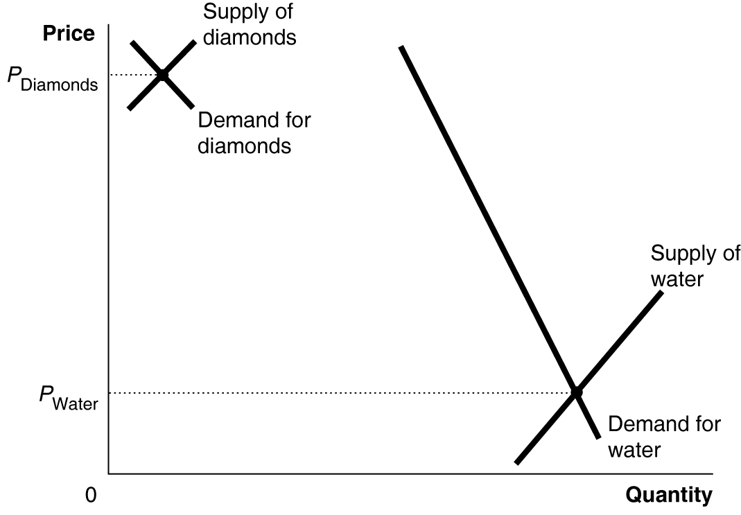
3.6 Begin by drawing two supply curves. Label one “Supply of Mantle autographs” and the other “Supply of Ford autographs.” Make sure that the Mantle supply curve is much farther to the right than the Ford supply curve. Based on the supply curves you have just drawn, think about how it might be possible for the market price of Ford autographs to be lower than the market price for Mantle autographs. The only way this can be true is if the demand for Mantle autographs is much greater than the demand for Ford autographs. Draw on your graph a demand curve for Mantle autographs and a demand curve for Ford autographs that will result in an equilibrium price of Mantle autographs that is higher than the equilibrium price of Ford autographs.
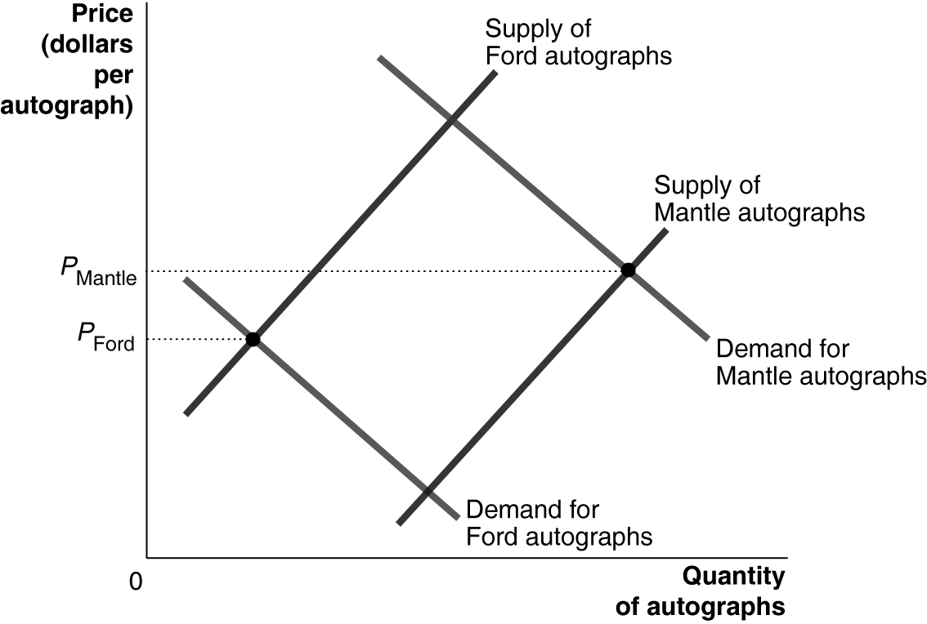
3.7 The demand for the U.S. version of Amazing Fantasy No. 15 comic relative to the demand for the U.K. version of the comic must be even greater than the supply of the U.S. version of the comic relative to the supply of the U.K. version of the comic. The graph below shows a greater supply of the U.S. version of the comic than the supply of the U.K. version and shows a much greater demand for the U.S. version of the comic than the demand for the U.K. version.
3.8 No. It only means that consumers who are willing to pay the equilibrium price were able to purchase the good, and sellers who are willing to accept the equilibrium price were able to sell the good. Consumers would have been happier paying less. And there are likely to be consumers who want the good but are not willing (or able) to pay the market price. Similarly, sellers would be happier to receive a higher price than the equilibrium price, and there may be sellers who are only willing to sell at a higher price and, therefore, do not participate in the market.
3.9 a. A “glut” means a surplus. At current steel prices, the quantity supplied of steel is greater than the quantity demanded of steel.
b. A glut or surplus causes prices to fall.
c. No, with quantity supplied greater than quantity demanded, steel companies will eventually have to reduce steel prices, thereby increasing quantity demanded and decreasing quantity supplied, which will eliminate the glut.

3.4 | The Effect of Demand and Supply Shifts on Equilibrium  Learning Objective: Use demand and supply graphs to predict changes in prices and quantities.
Review Questions
4.1 a. When the demand curve shifts to the right, the equilibrium price and equilibrium quantity both rise. The graph below on the left illustrates this case.
b. When the supply curve shifts to the left, the equilibrium price rises, but the equilibrium quantity falls. The graph below on the right illustrates this case.
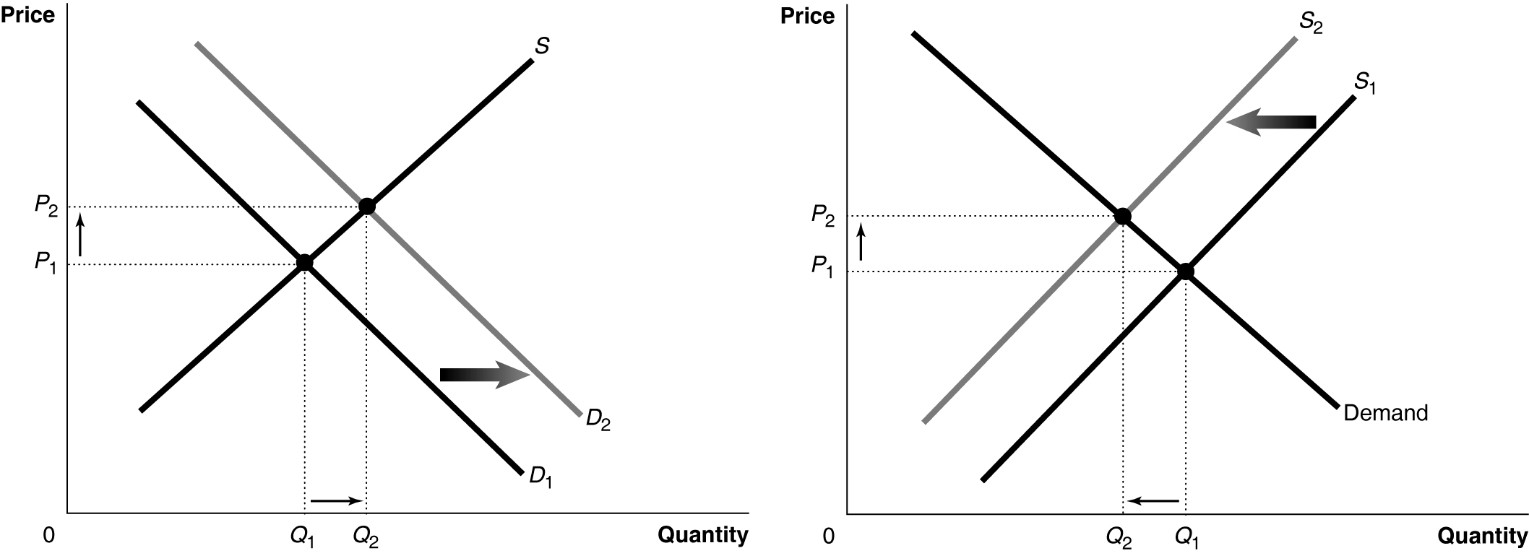
4.2 If the demand curve shifts to the right more than the supply curve does, the equilibrium price will rise. Figure 3.11 (a) on page 88 of the text illustrates this case. If the supply curve shifts to the right more than the demand curve, the equilibrium price will fall. Figure 3.11 (b) on page 88 of the text illustrates this case.
Problems and Applications
4.3 The increase in the demand for corn raised the price of corn and led some farmers to plant more acreage in corn and less in rice. The reduction in acreage to rice will shift the supply curve of rice to the left, raising the equilibrium price of rice. To the extent that corn and rice are also substitutes in consumption, the increase in the price of corn will shift the demand for rice to the right, but the overall effect in the rice market will be a decrease in the quantity of rice given the 3% reduction in acres planted in rice. As shown in the graph below, the decrease in supply and the increase in demand for rice both increase the price of rice and with the reduction in quantity of rice the decrease in the supply of rice will be larger than the increase in the demand for rice.

4.4 a. The reduction in the planting of new grape vines in recent years will shift the supply curve for wine to the left. The implication of the statement that “Americans kept drinking more wine” is that the demand curve for wine has shifted to the right. Americans drinking more wine could imply that the equilibrium quantity of wine has increased with the shift to the right of the demand curve being larger than the shift to the left of the supply curve. However, if all we know is that the supply curve for wine shifted to the left, while the demand curve for wine shifted to the right, without knowing the size of the shifts we cannot be certain whether the equilibrium quantity of wine will increase or decrease.
b. With the supply curve for wine shifting to the left and the demand curve for wine shifting to the right, the equilibrium price of wine will increase, as shown in the graph below. The graph shows the equilibrium quantity of wine increasing, but that depends on the demand curve shifting to the right farther than the supply curve shifts to the left.
4.5 a. The demand curve for natural gas will shift to the left and the supply curve for natural gas will shift to the right. We cannot be certain whether the equilibrium quantity of natural gas will increase or decrease without knowing the size of the shifts. The effect of the demand curve shifting to the left is to decrease the equilibrium quantity, and the effect of the supply curve shifting to the left is to increase the equilibrium quantity. In the graph on the next page, the two effects offset and the equilibrium quantity is unchanged. Other results are possible, though.
b. Yes, we know with certainty that the equilibrium price of natural gas will decrease. Both the demand curve shifting to the left and the supply curve shifting to the right will contribute to causing a decrease in the equilibrium price of natural gas.
4.6 Draw a demand and supply graph showing the market equilibrium in the winter. Label both the demand and supply curves “winter,” and label the equilibrium price created by these curves “winter.” Add to your graph the demand curve for summer, making sure it is to the right of the winter demand curve. Look at the graph to see how the equilibrium price in the summer could be lower than the equilibrium price you have established for the winter. The only way for this to happen is for the summer supply curve to shift to the right by enough to cause the equilibrium price to be lower in the summer than it is in the winter. The demand for watermelon does increase in the summer compared with the winter, but the increase in the supply of watermelon in the summer is even greater, so the equilibrium price falls.
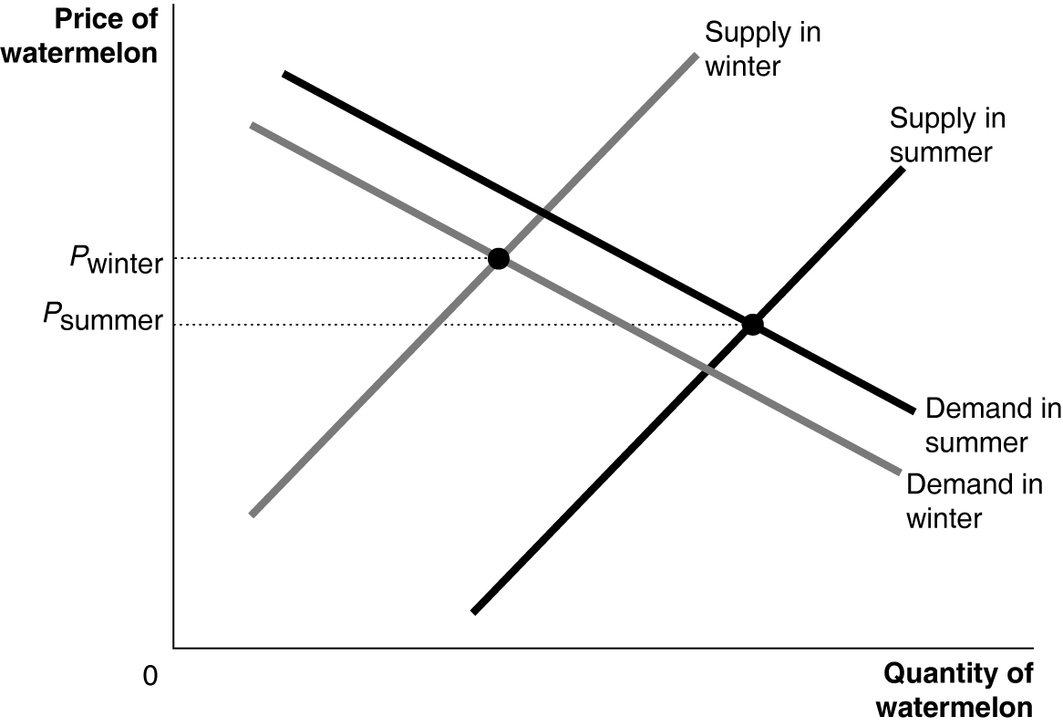
4.7 Draw a demand and supply graph showing the market equilibrium before Labor Day. Label both the demand and supply curves “Before Labor Day,” and label the equilibrium price created by these curves “Before Labor Day.” Add to your graph the demand curve for “After Labor Day,” making sure it is to the left of the “Before Labor Day” demand curve, as the vacationers have gone home. Add to your graph the supply curve for after Labor Day, making sure it is to the right of the “Before Labor Day” curve because fishing conditions are good. Because the demand curve has shifted to the left and the supply curve has shifted to the right (or perhaps stayed the same, if the good fishing conditions are a continuation from the summer conditions), the equilibrium price will definitely decrease in the fall.
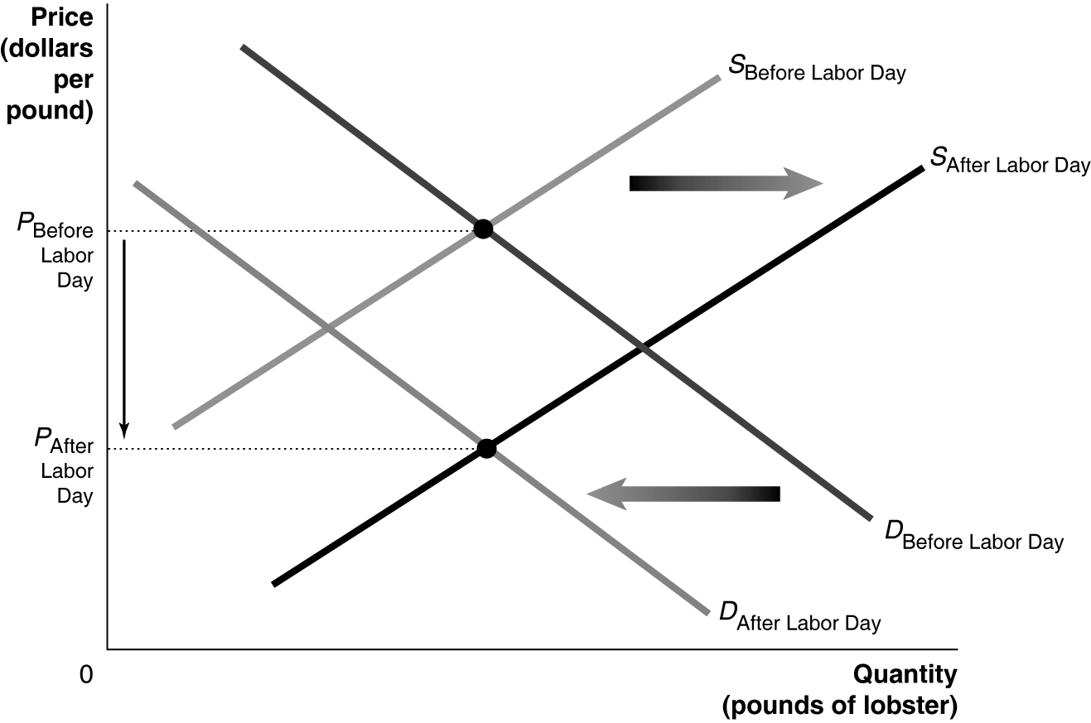
4.8 a. The lower demand as cars become more efficient shifts the demand curve for gasoline to the left. The growth in oil production from hydraulic fracturing shifts the supply curve for gasoline to the right as gasoline is produced (refined) from oil. These shifts are shown in the graph below.
b. We can be certain that the equilibrium price of gasoline will decrease because the shifts of both the demand curve and the supply curve cause the price of gasoline to fall. We cannot be certain whether the equilibrium quantity of gasoline will increase or decrease because it depends on the relative magnitudes of the shifts in the demand curve and the supply curve. The previous graph shows the equilibrium quantity of gasoline increasing slightly, but if the shift of the demand curve is greater than the shift of the supply curve, the equilibrium quantity of gasoline will decrease.
4.9 a. The apple producer was assuming that apples and bananas are substitutes. The cheap bananas lead people to substitute away from buying apples and toward buying bananas.
b. The tariff on imported bananas, as shown in the graph below on the left, shifts the supply curve for bananas to the left, increasing the equilibrium price and decreasing the equilibrium quantity of bananas. As shown in the graph below on the right, the higher price of bananas shifts the demand curve for apples to the right, increasing both the equilibrium price and the equilibrium quantity of apples.
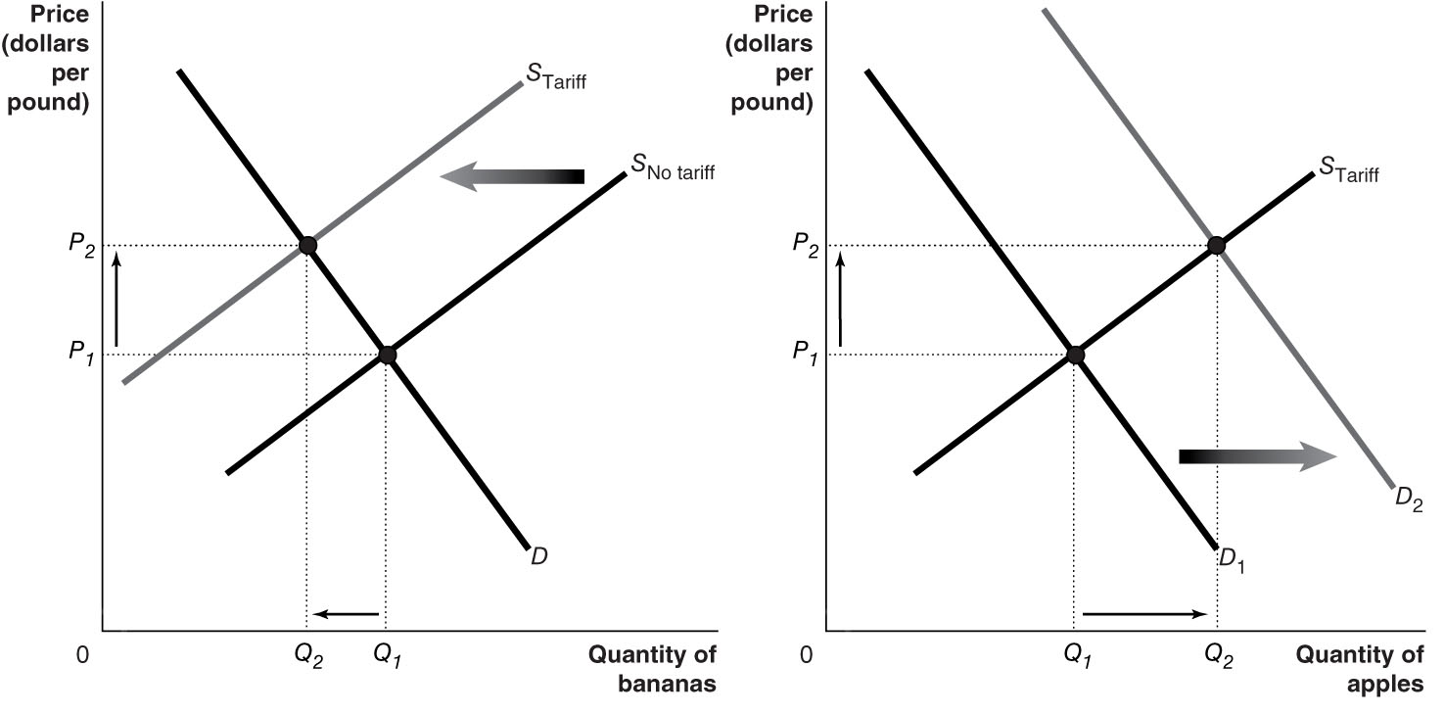
4.10 The student’s analysis is incorrect. The equilibrium quantity will definitely increase because both the demand curve and the supply curve will shift to the right, but the change in the equilibrium price is uncertain. The equilibrium price could increase, decrease, or remain the same depending on the magnitude of the shifts in the demand and supply curves. The graph below shows shifts of equal magnitude in the demand and supply curves, so the equilibrium price in this case does not change.
4.11 Refrigeration allowed for the storage of perishable products. In the graph on the left below, storage removes some of the supply during the peak season, shifting the supply curve to the left from S₁ to S₂ and driving the price up from P₁ to P₂. During the off-season, the refrigerated supply could be offered for sale, shifting right the relatively small supply from S₃ to S₄ and causing the price to fall from P₃ to P₄, a shown in the graph on the right below.
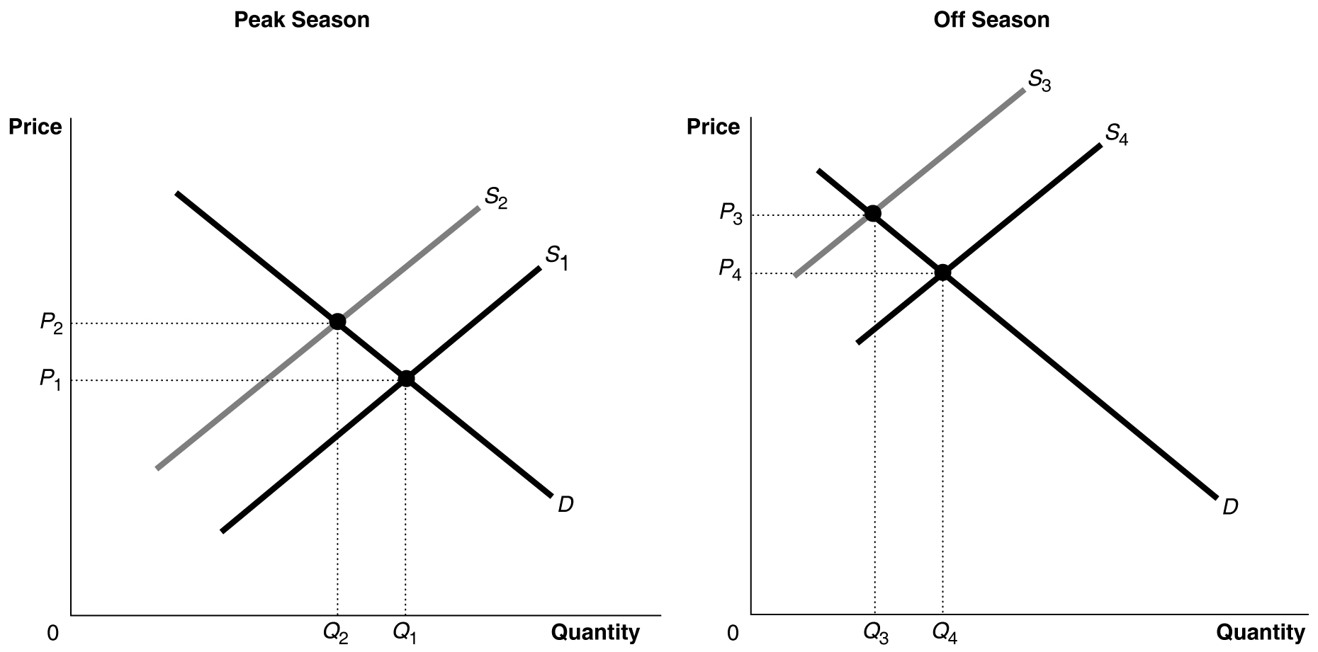
4.12 With the equilibrium price increasing and the equilibrium quantity decreasing, we know that the supply curve definitely shifted to the left in 2014. It is possible that the demand curve also shifted. But if the demand curve had shifted to the right by more than the supply curve shifted to the left, then the equilibrium quantity would have increased rather than decreased. Similarly, if the demand curve had shifted to the left by more than the supply curve shifted to the left, then the equilibrium price would have decreased rather than increased. We can conclude that the supply curve must have shifted by more than the demand curve.
4.13 The student’s reasoning is incorrect. He should have said: “Increased production shifts the supply curve to the right and leads to a lower equilibrium price but a higher equilibrium quantity and therefore a larger quantity demanded. The increase in quantity demanded is a result of a supply curve shifting to the right and a movement along the demand curve, but the demand curve does not shift.”
4.14 The student’s analysis is incorrect—the shift from D₁ to D₂ will not happen. There will be a movement along the demand curve, D₁, due to the price change, but the demand curve will not shift. Recall that a shift in the supply curve causes a change in equilibrium price, but the change in price does not cause a further shift in demand.
4.15 a. Scenario a. is shown in graph 1. The demand for Pepsi rises because a decrease in the supply of Coke will increase the price of Coke, which is a substitute for Pepsi. The shift in the demand curve for Pepsi results in a movement along the supply curve for Pepsi.
b. Scenario b. is shown in graph 4. The demand for Pepsi falls when incomes fall assuming Pepsi is a normal good. The shift in the demand curve for Pepsi results in a movement along the supply curve for Pepsi.
c. Scenario c. is shown in graph 3. An improvement in technology reduces the cost of producing Pepsi and shifts the supply curve for Pepsi to the right.
d. Scenario d. is shown in graph 2. A rise in an input’s price shifts the supply curve for Pepsi to the left.
4.16 The rising costs will cause the supply curve to shift to the left, from S₁ to S₂, while the improvement in quality will cause the demand curve to shift to the right from D₁ to D_{2.} Because we don’t know if the demand curve shifts to the right more than the supply curve shifts to the left, we don’t know if the equilibrium quantity purchased will increase or decrease. If the shift in the supply curve is greater, as shown in the figure below, the equilibrium quantity will fall. We do know that the equilibrium price of childcare will rise as a result of the regulation.
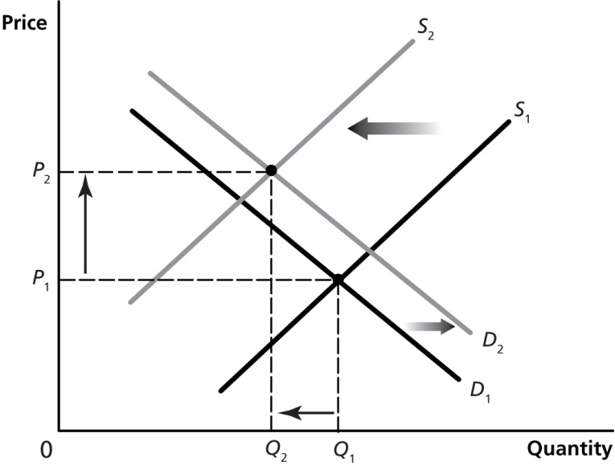
4.17 The graph with the demand curve shifting to the right from D₁ to D₂ best represents the market for hotel rooms at a ski resort during the peak season of the winter months. If hotel rates stayed at their summer level of P₁, there would be a shortage of hotel rooms during the winter months.
4.18 The graph with the vertical demand curve is more likely to represent the market for the life-saving drug. If the price of this good rises, patients are unlikely to reduce the quantity they demand, but if the price of the Tesla automobiles rises, households will reduce the quantity they demand as they switch to buying other cars.

