CHAPTER 1 | Economics:
Foundations and Models
Solutions to Chapter 1 Appendix
1A.1 a. The relationship is negative because as price decreases, the quantity of pies purchased increases.
b.
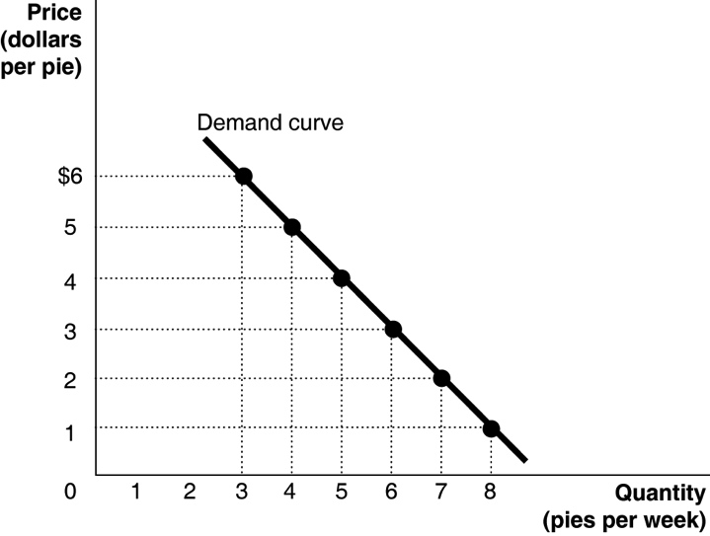
c. The slope = ∆y/∆x = rise/run = −1/1 = –1.
1A. 2
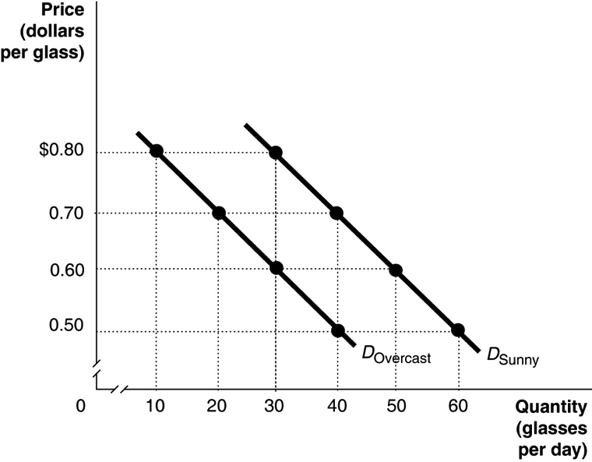
1A.3 Answers will vary somewhat depending on the values determined from the time-series graph. The calculations below use Ford sales rounded to the nearest millions as shown in the table below.

Year | Ford’s Auto Sales
2001 | 7.0
2002 | 7.0
2003 | 6.7
2004 | 6.8
2005 | 6.8
2006 | 6.6
2007 | 6.6
2008 | 5.4
2009 | 4.9
2010 | 5.5
2011 | 5.7
2012 | 5.7

Period Percentage Change
2001 to 2002 [(7.0 – 7.0)/7.0] × 100 = 0.0%
2002 to 2003 [(6.7 – 7.0)/7.0] × 100 = –4.3%
2003 to 2004 [(6.8 – 6.7)/6.7] × 100 = 1.5%
2004 to 2005 [(6.8 – 6.8)/6.8] × 100 = 0.0%
2005 to 2006 [(6.6 – 6.8)/6.8] × 100 = −2.9%
2006 to 2007 [(6.6 – 6.6)/6.6] × 100 = 0.0%
2007 to 2008 [(5.4 – 6.6)/6.6] × 100 = −18.2
2008 to 2009 [(4.9 – 5.4)/5.4] × 100 = −9.3%
2009 to 2010 [(5.5 – 4.9)/4.9] × 100 = 12.2%
2010 to 2011 [(5.7 – 5.5)/5.5] × 100 = 3.6%
2011 to 2012 [(5.7 – 5.7)/5.7] × 100 = 0.0%

We can conclude that sales fell at the fastest rate between 2007 and 2008.

1A.4 [($14,418 − $14,834)/$14,834] × 100 = −2.8%
The percentage change in real GDP from one year to the next is the economy’s growth rate.
1A.5 a.
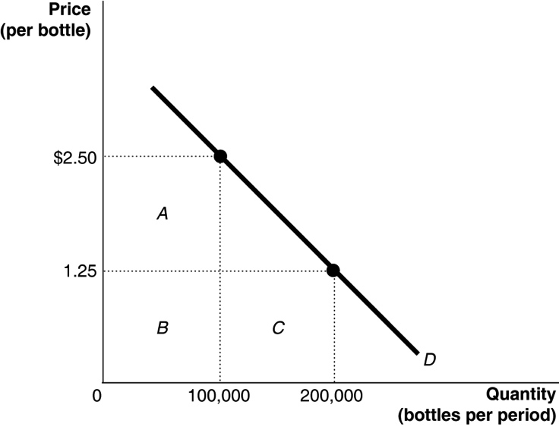
b. At $2.50, the total revenue equals rectangles A + B = $250,000 (because $2.50 × 100,000 = $250,000). At $1.25, the total revenue equals rectangles B + C = $250,000 (because $1.25 × 200,000 = $250,000).
1A.6 The triangle’s area = (0.5) × (175,000 – 115,000) × ($2.25 − $1.50) = 0.5 × 60,000 × $0.75 = $22,500.
1A.7 The slope is calculated using the formula:
At point A: rise = 300 − 175 = 125, run = 7 − 5 = 2. Therefore, the slope = 125/2 = 62.5.
At point B: rise = 900 − 700 = 200, run = 14 – 12 = 2. Therefore, the slope = 200/2 = 100.

